Navorina News

June 2025
Navorina Nursing Home 5 Macauley St Deniliquin activities@navorina.com.au
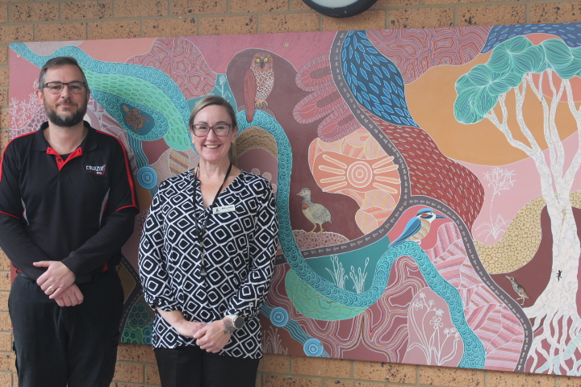 | IN THIS ISSUE  - Editor’s Desk.………… 2  - Month in Review ………. 3  - Upcoming Events ……. 5  - June Birthdays ………. 6  - A Poem to Share.……. 7  - Noticeboard ……………. 8  - Laughing Matters ……... 10  - Spotlight ………………… 11  - Word Search …………… 12



Editor’s Desk
Hello Residents, Families and Friends!
The Board of Navorina is pleased to announce the appointment of Melissa Bromley to the position of Chief Executive Officer (CEO), commencing Monday 28 April. Melissa is local to the Murray region and brings extensive experience in health-related roles including Aged Care, most recently working for the Aged Care industry’s peak body, Ageing Australia. Melissa is a registered nurse with a master’s in business administration with a strong focus on leadership and strategy. Melissa brings a wealth of senior leadership experience and knowledge of aged care. She is passionate and driven to deliver the best quality of care to our ageing Australians. Melissa's values are highly synergistic with Navorina's mission, vision and valuesThe appointment follows a lengthy recruitment process with a strong focus on ensuring we found the right candidate for the future of Navorina and our residents. The Board is excited about this appointment as Navorina works towards the future with a new Aged Care Act and its Strengthened Quality Standards from July this year and continuing to focus on delivering quality care to our residents. Please join us in extending a warm welcome to Melissa.
The Board of Navorina wishes to formally announce that Mr. Neville Purtill has stepped down from his role as Chairman of the Board. We extend our gratitude to Neville for his dedicated leadership and the valuable contributions he has made during his tenure as Chair. We are pleased to confirm that Neville will continue to serve as a member of the Navorina Board, where his experience and insight will remain a valued asset. The Board is also pleased to announce the appointment of Mr. Matthew Watts as the new Chair of the Board. Matthew brings a strong background in governance and community service, and we are confident that his leadership will guide Navorina through its next phase of growth and development. We thank both Neville and Matthew for their continued commitment to Navorina’s mission, vision and values.
A quick reminder if you have yet to complete your resident / relative survey, could you please do so ASAP. We are excited to have families join us for morning tea on the first Sunday of each month at 10am in the cafe area, Sandra will be there making some delicious coffees, and a sweet treat will be provided by Navorina.
With warm wishes and joyful reflections,
Bernadette

Month in Review
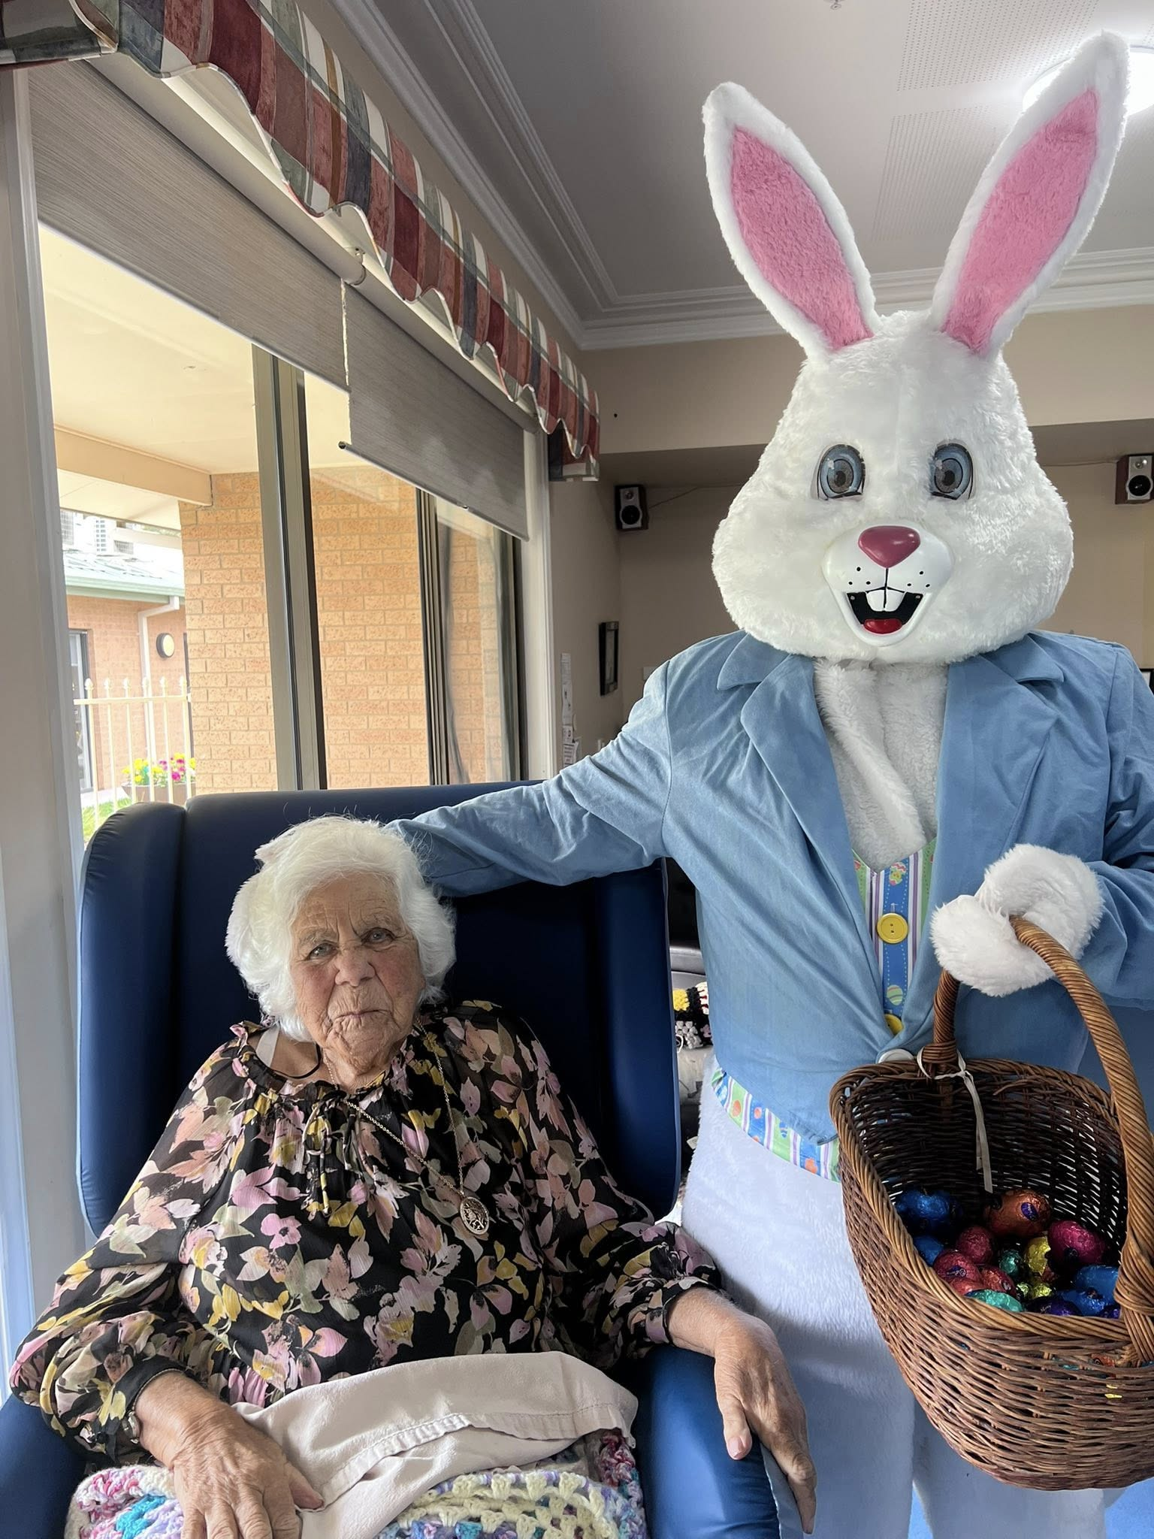
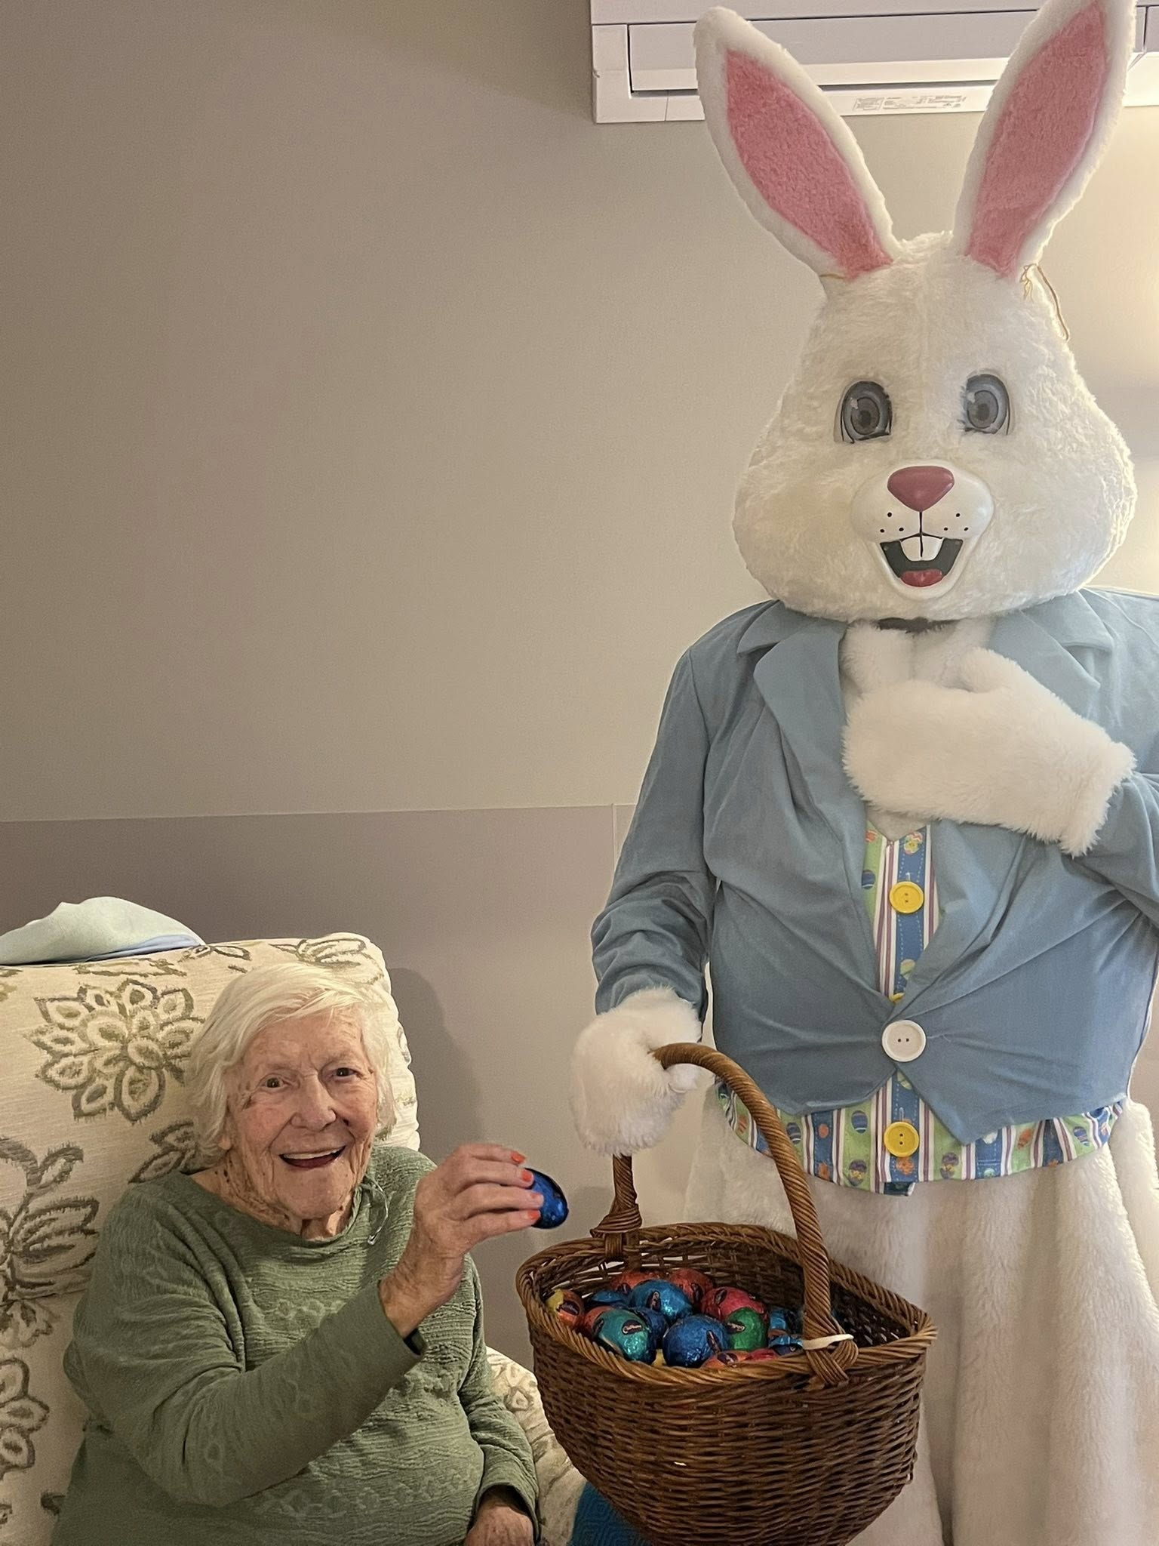
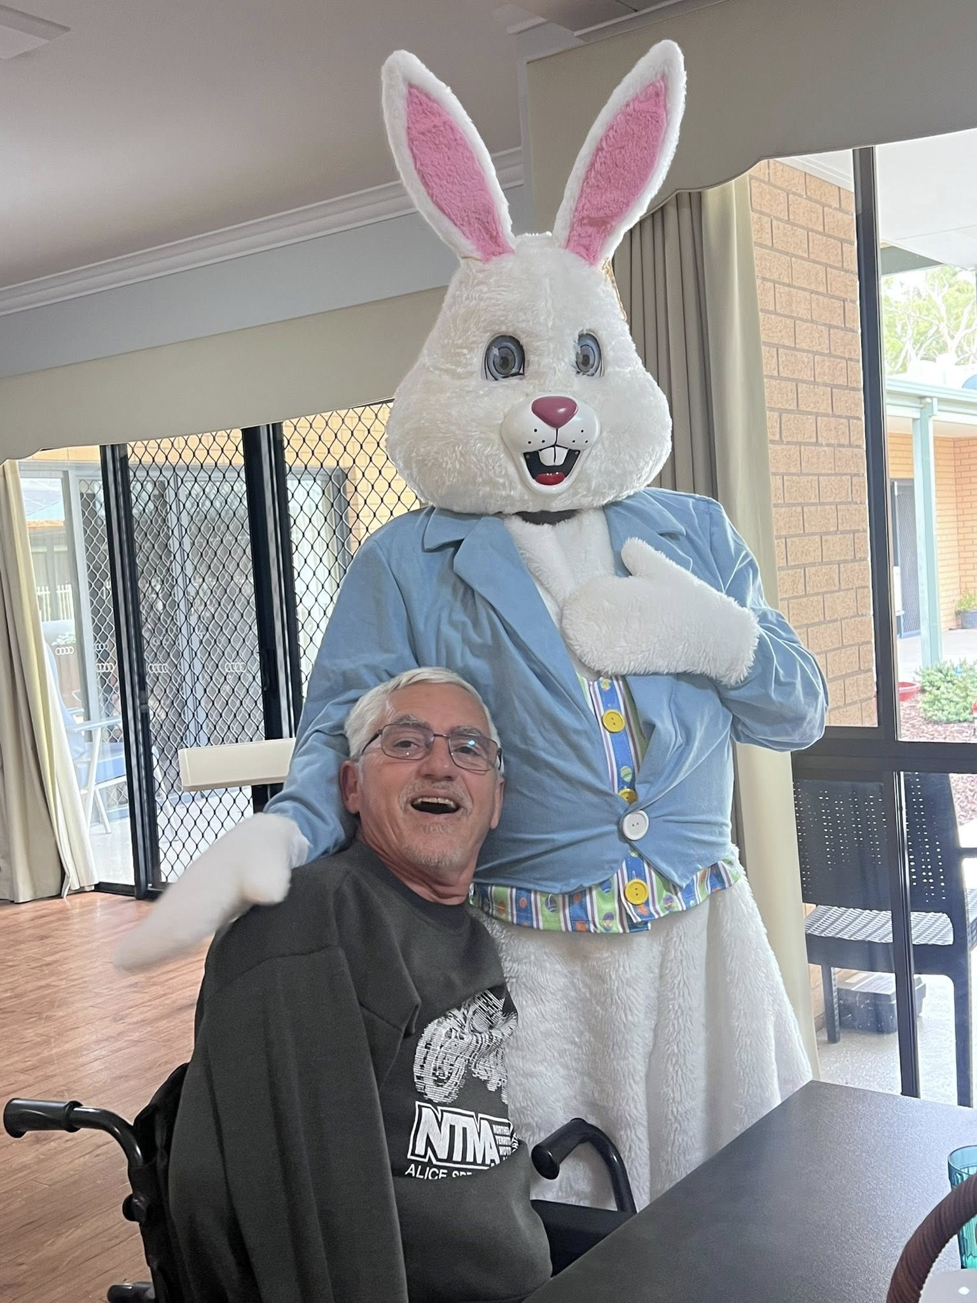
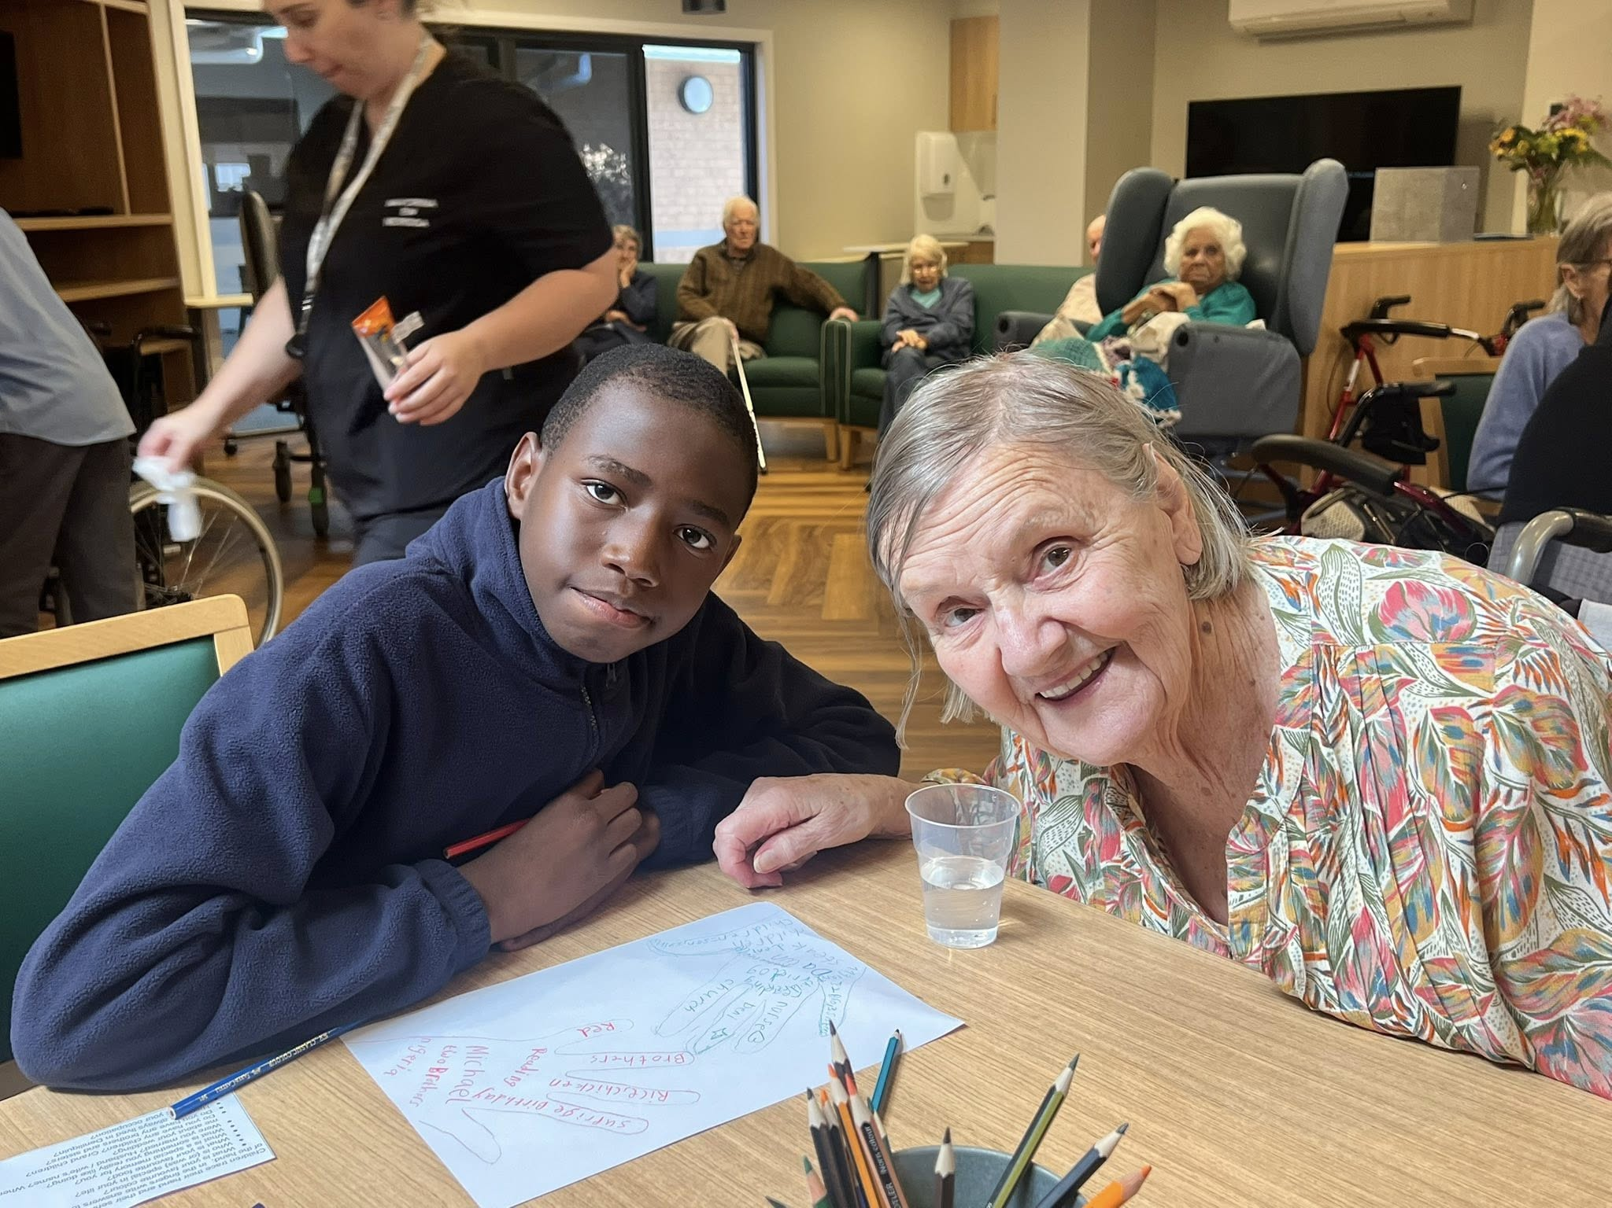
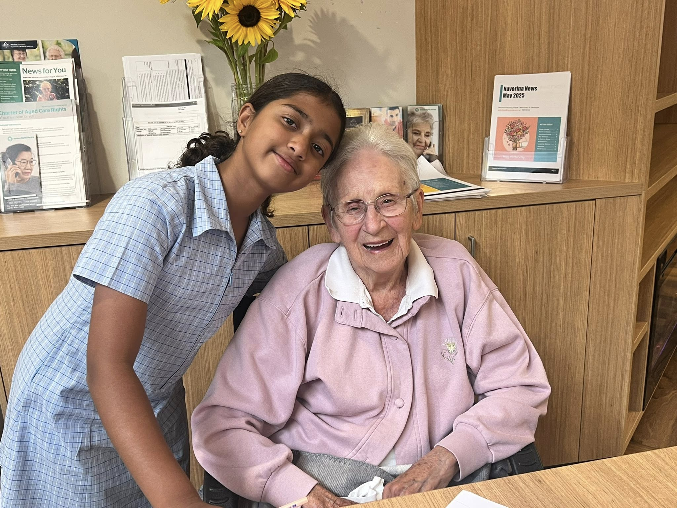
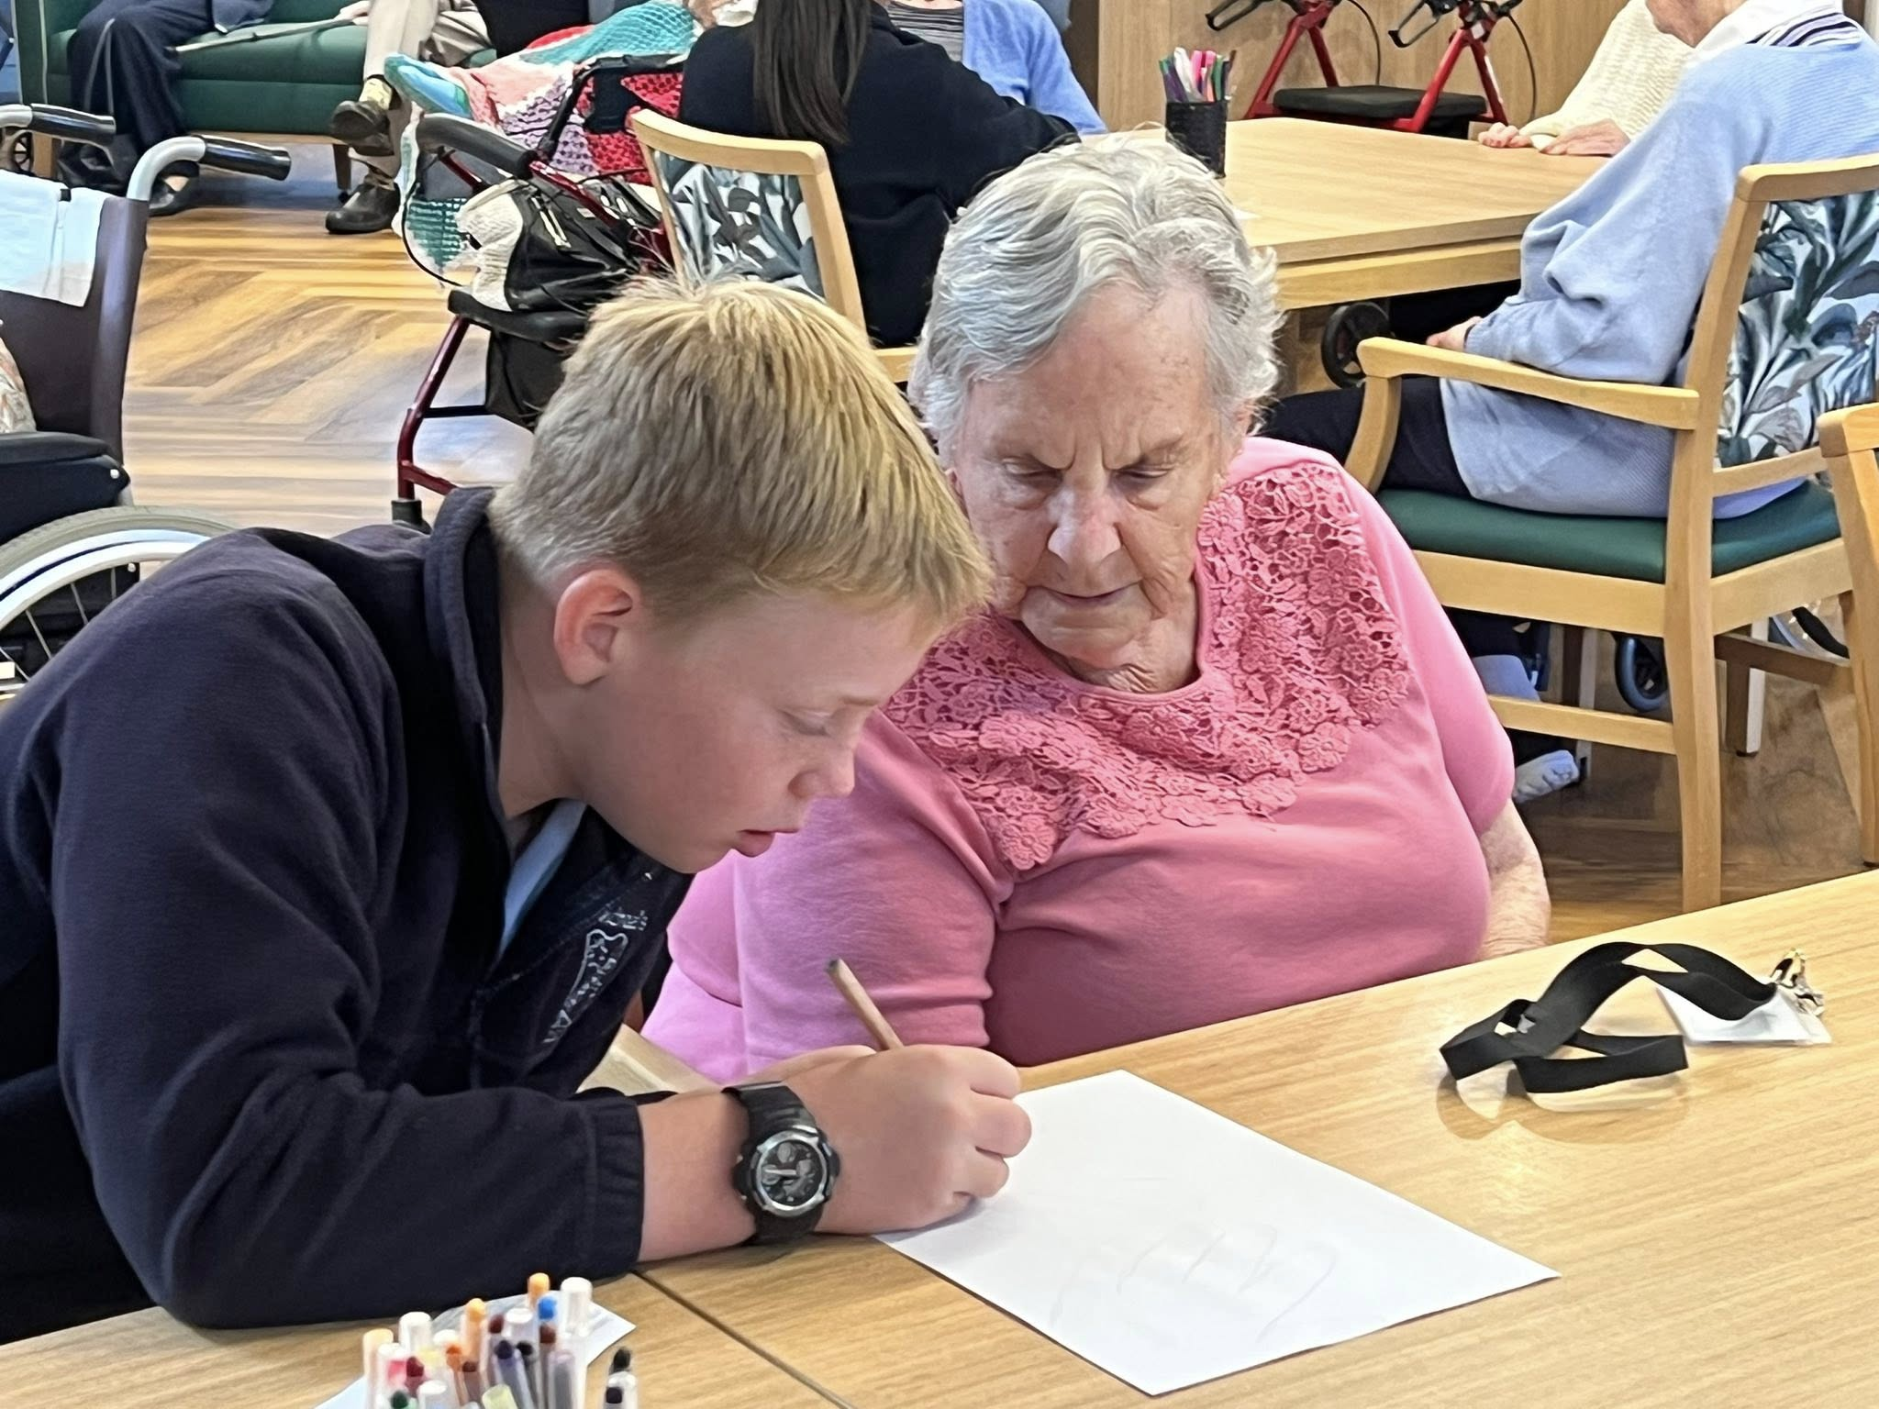
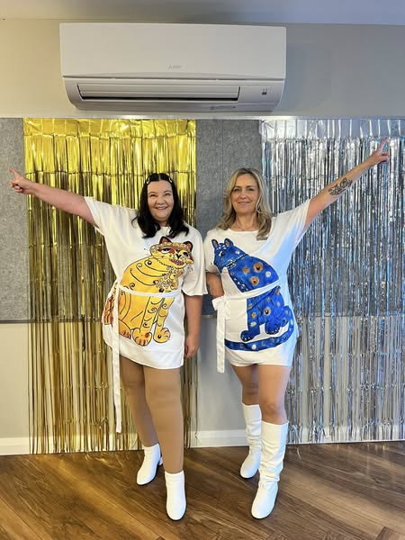
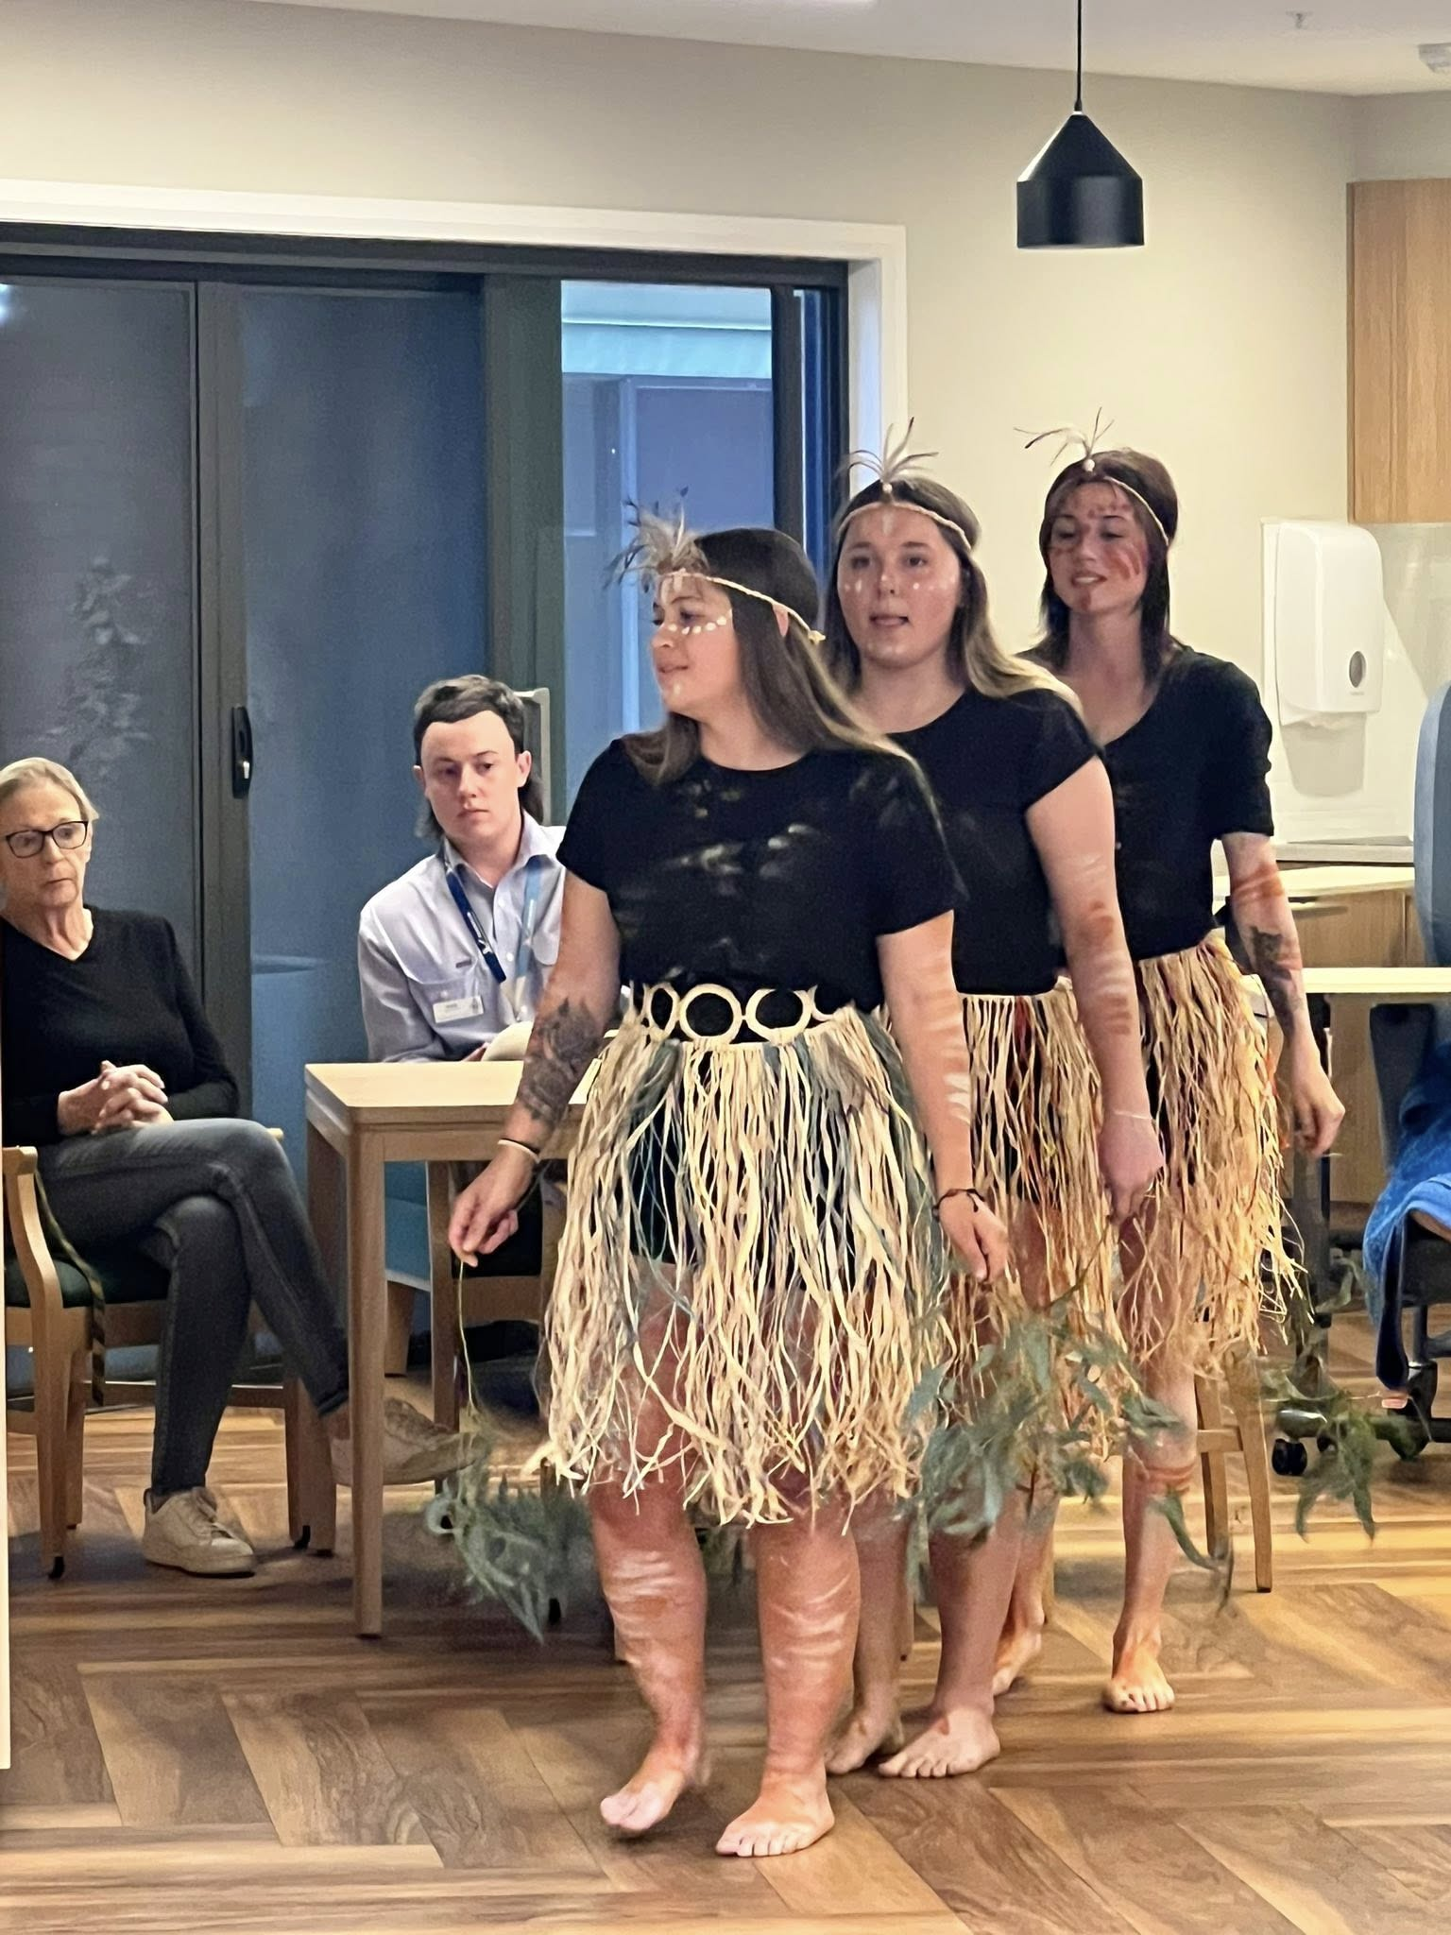
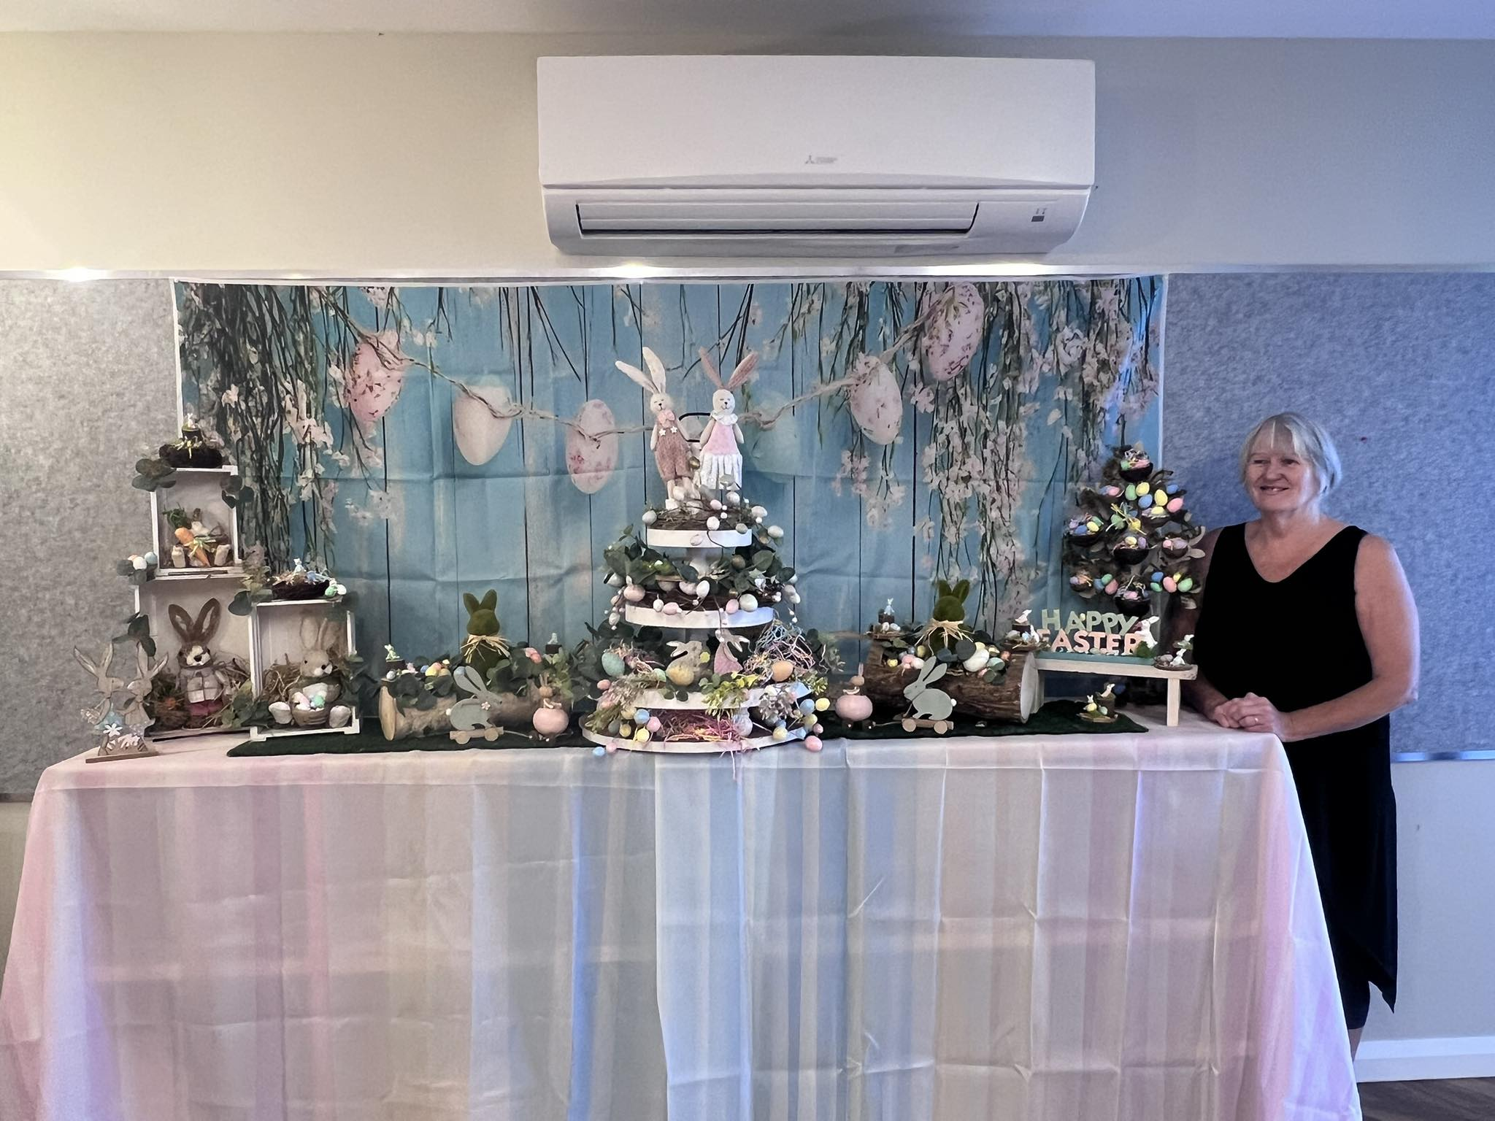

Month in Review

Upcoming Events


Family & friends coffee Morning
Sunday 1st of June 10am, Café area -all family & friends welcome to attend.
Resident’s Meeting
Tuesday 17th of June 2:30pm, Hunter Dining
King’s Birthday Afternoon Tea
Tuesday 10th of June 3pm
Saturday 28th June 2pm Entertainment
Gedupndans Peter Band
Special Days

1st World Milk Day
2nd Italian National D
5th World Environment Day
6th D-Day
8th World Oceans Day
15th Father’s Day (US, CA, UK)

19th Emancipation Day (US)
21st World Music Day

30th Wimbledon

21st Memorial Day

Intergeneration Program Thursday 5th & 19th 2pm
Southern Voices of Melbourne Choir Sunday June 8th at 2pm -All welcome

Regular Events

Happy Hour every Friday 2pm -3pm
Catholic Mass 26th June 10am
Hairdresser every second Thursday from 9am
Men’s Group every Monday at 2pm
Bingo! Every Tuesday & Friday 10am
Art / Craft every Tuesday at 2.30pm



June Birthdays

In June, we celebrate birthdays with:

- Ross Danckert
- Rus Fisher
- Greg Gamble
- Gary Eason
- Margaret Knuckey

Gemini (May 21 – Jun 20)
Geminis love to learn and they never stop wondering about the unexplained.
Cancer (June 21 – July 22)
Cancer personalities are very emotional and sensitive, and care deeply about matters of the family and their home.

June Trivia
June’s name comes from the Roman goddess Juno, protector of women and marriage.
In 1969, Neil Armstrong was named the first civilian selected for the astronaut program—and in just one month, he would make history.
June 1st, 1967, saw the release of The Beatles’ iconic album Sgt. Pepper’s Lonely Hearts Club Band—a musical landmark that still resonates today.
The Birth of the Italian Republic
On June 2, 1946, Italians voted to become a republic, marking a fresh start rooted in democracy. Festa della Repubblica celebrates this with parades, music, and national pride.

Poem to Share

Don’t Quit
John Greenleaf Whittier
When things go wrong, as they sometimes will,
When the road you’re trudging seems all uphill,
When the funds are low and the debts are high,
And you want to smile, but you have to sigh,
When care is pressing you down a bit—
Rest if you must, but don’t you quit.

Life is strange with its twists and turns,
As every one of us sometimes learns,
And many a failure turns about
When he might have won had he stuck it out;
Don’t give up though the pace seems slow—
You may succeed with another blow.

Success is failure turned inside out—
The silver tint of the clouds of doubt,
And you never can tell how close you are,
It may be near when it seems so far;
So stick to the fight when your hardest hit—
It’s when things seem worst that you must not quit.

New Residents
A very warm welcome to:
- Mrs Glenys Chessells
- Mrs Norma Barnett
We hope that you enjoy your time here!
Continuous Improvement
Residents, families and friends are reminded that there are a few avenues available for you to express your views, suggestions and complaints.
There are feedback forms available in the front foyer, Café area or ask a staff member. We are happy to receive feedback at any time and strongly encourage everyone to contribute so that we can ensure that we continue to do the BEST we can.

Noticeboard

New Staff
A warm welcome also goes to the people who joined our team in the past month!
- Aswanii -RN
- Anju -RN
- Joshua -Agency RN
- Lisa Coyle -EEN
- Jules -EEN
- Dee -AIN
We hope that you enjoy your time here!

Can you Contribute?
Contributions to our newsletter are encouraged and appreciated!
Articles, photos, reports on community outings, staff news, trivia, poems and amusing stories relating to residents and staff are most welcome.
Please hand in your submission to Lifestyle, or email activities@navorina.com.au
Thank you!

In Memoriam
To the families and friends of our late residents—may you be comforted by the knowledge that your loved ones are at peace.
- Mr Noel Robertson
- Fay Mercer

Noticeboard
LIBRARY SERVICE
We have a mobile library service that delivers & picks up library books to residents. If you would like this service, please talk to a Lifestyle staff member.
THANK YOU
We would like to issue a heartfelt thanks to relatives and volunteers who support us day in and day out. You make such a difference, and we so very much appreciate your time and energy.

Family Breakfast
All families & friends are invited to join us for breakfast each Thursday morning for our BBQ breakfast and delicious coffee.

Hairdresser
We have a hairdressser who attends every Thursday. If you would like an appointment please talk to reception or ask a staff member to write your name down in the hairdressers book.

Entertainment
On Saturday 28th June, we have Gedupndans Peter performing for residents at 2pm. Familiies and friends are invited to attend and enjoy the music.

Cultural Celebration
In the month of May / June we celebrate National Reconciliation Week. 27th May – 3rd June.



Laughing Matters

The Fisherman
Joe packed away his fishing gear in a bad mood because after all day fishing, he hadn’t caught a thing.
He passed by the fishmonger and asked for a large fish.
The fishmonger said: “What kind?”
“Any kind” Joe replied.
The fishmonger said: “You better take a Snapper because your wife was here earlier and told me if you came by to give you a snapper. That’s what she feels like eating tonight.”
The Nurse
A man was going frantically down the hall of the hospital in his wheelchair, just before his operation.
A nurse stopped him and asked: “What’s the matter?”
He said, “I heard a nurse say, ‘It’s a very simple operation, don’t worry, I’m sure it will be all right.’”
“She was just trying to comfort you, what’s so frightening about that?”
“She wasn’t talking to me. She was talking to the doctor!”
The Tramp
A gentleman was walking home when a tramp approached him and asked for two dollars.
The gentleman asked: ‘For you to buy booze?’
‘No, sir’ replied the tramp.
The gentleman probed: ‘For you to gamble then!’
‘No, sir’ replied the tramp.
‘Then, will you come home with me so my wife can see what happens to a man who doesn’t drink or gamble?’
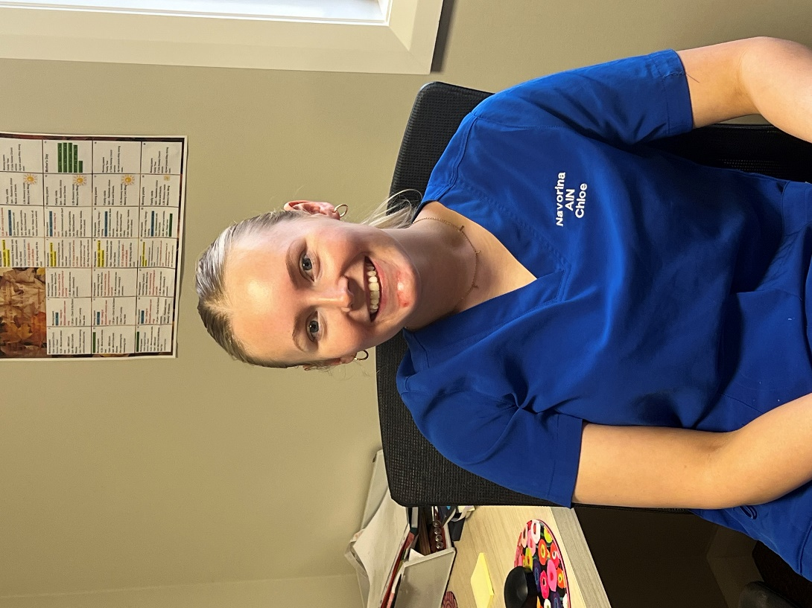

Spotlight

Chloe Brown

I am studying for my Bachelor of Nursing at Deakin University Melbourne. I have just started working in Lifestyle, I also work as an AIN. At the weekend I play netball for the Rovers football Club.

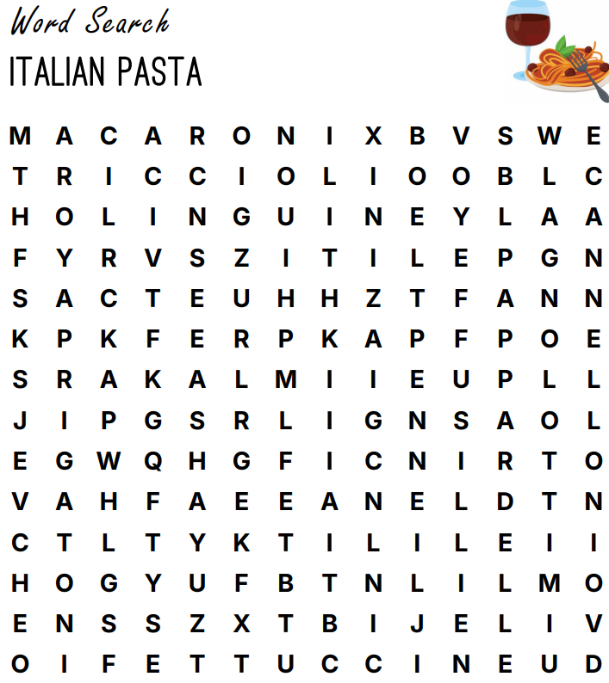

Spaghetti Fettuccine Penne Rigatoni
Macaroni Linguine Tagliatelle Farfalle
Vermicelli Fusilli Cannelloni Ziti
Tortellini Agnolotti Pappardelle Riccioli

