Navorina News

January 2026

Navorina Nursing Home 5 Macauley St Deniliquin 58813944 activities@navorina.com.au
 | IN THIS ISSUE  - Editors Desk.………… 2  - Month in Review ………. 3  - Upcoming Events ……. 5  - January Birthdays ……. 6  - A Poem to Share ……. 7  - Noticeboard ……………. 8  - Laughing Matters ……. 10  - Spotlight ………………… 11  - Quiz.……………………… 12

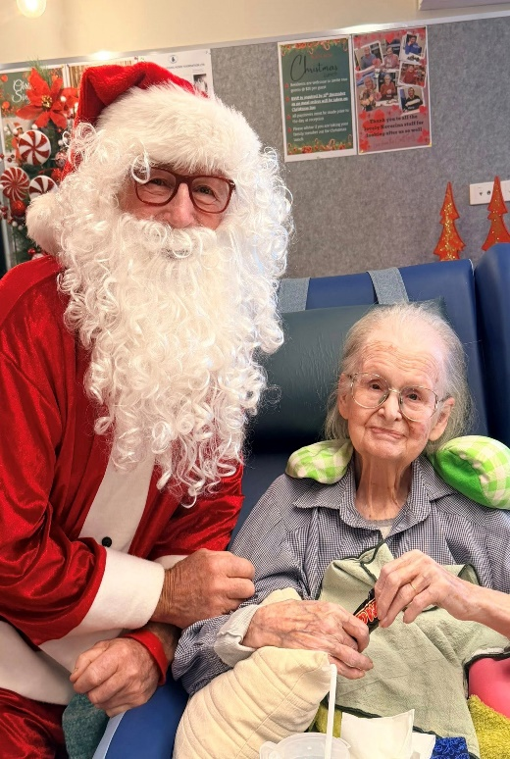

Editor’s Desk
Welcome to the first newsletter of 2026! January is a powerful month – time for reflection, renewal, and fresh possibility. As we step into the new year together, we pause to acknowledge the journey behind us and look ahead with optimism and purpose.
January represents more than turning of the calendar page. It is a moment to reset, to embrace new ideas, and to recognize the small breakthroughs that quietly shape our world each day. It is these moments- shared conversations, creative thinking, acts of kindness, and collective effort – that meaningful change begins.
As we gather in this space, we celebrate the strength of community, the lessons learned, and the opportunities that lie ahead. This year invites us to be inspired, to remain curious, and to continue building a future shaped by compassion, resilience, and connection.
Thank you for being part of our story. May 2026 be a year of growth, inspiration, and moments that truly matter.
Bernadette

What We’ve Been Up To

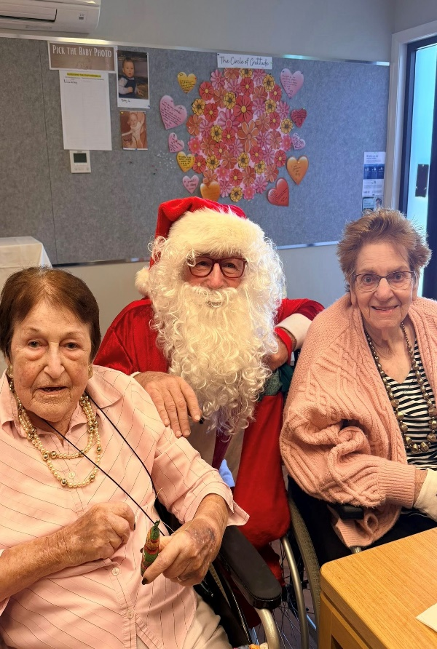
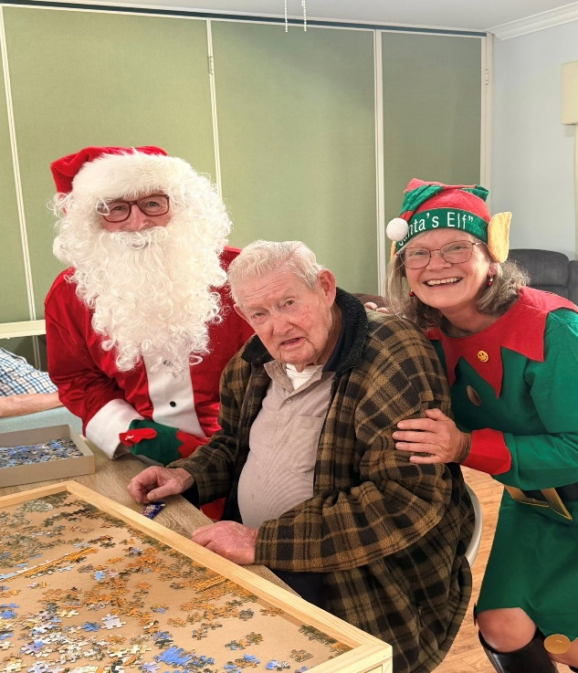
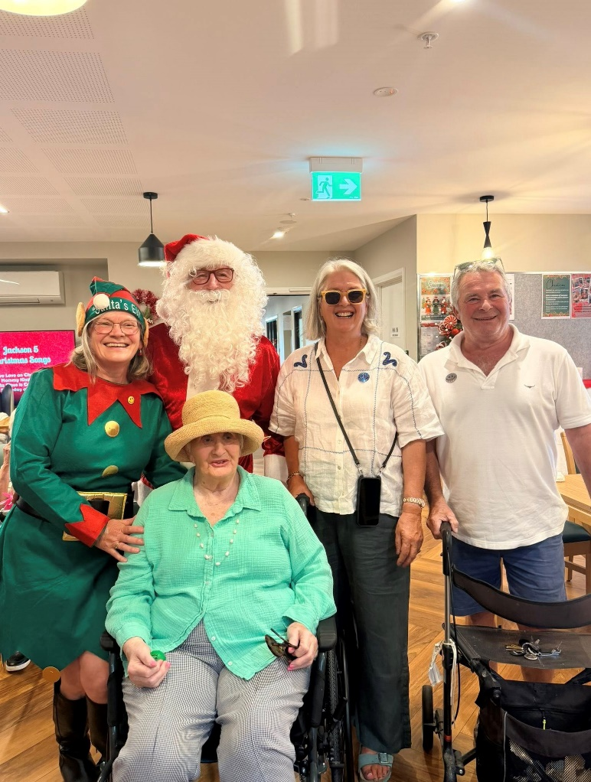
Visit from Santa Claus

Residents enjoyed a very special visit from Santa Claus and his Elf, who surprised everyone with small treats and chocolates. It was a joyful moment that bought lots of smiles and Christmas cheer.
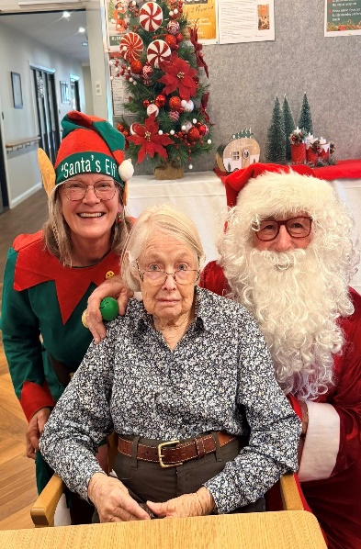
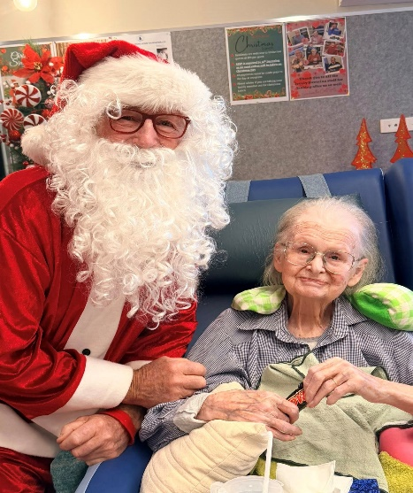
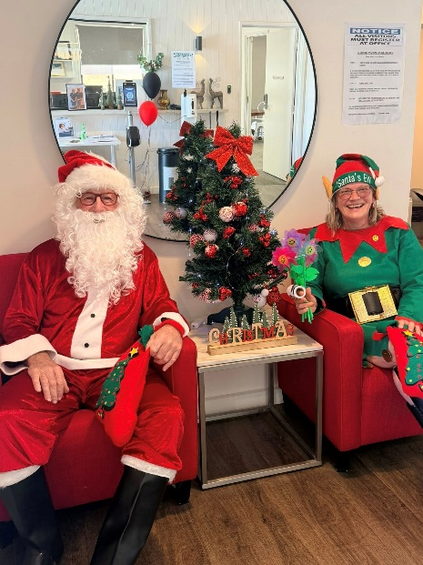
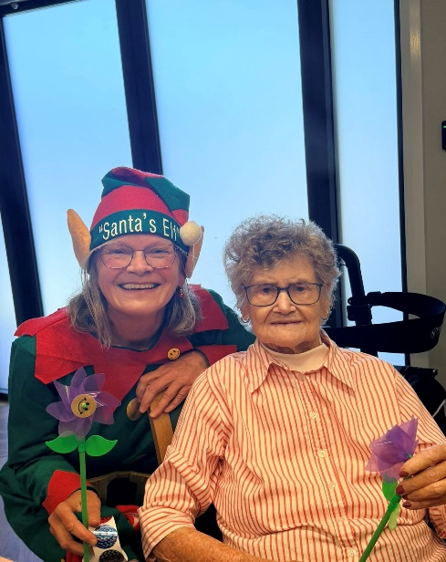

Life at Our Community


Regular Events

Happy Hour every Friday 2.30pm
Catholic Service last Thursday of the month 10am
Hairdresser every Thursday from 9am
Men’s Group every Monday at 2pm
Bingo! Every Monday 2pm & Tuesday 10am
Group Gentle exercise Monday & Friday mornings at 10.30am
Community Sing along every Thursday from the 14^{th of} January.
BBQ lunch each Monday at 12pm.
Anglican church service starts back from 2nd February 2026.


In January, we celebrate birthdays with:

- Gladys Mann
- Dorothy Gemmell
- Rose Bawden
- Janice Hattwell
- Ian McKenzie

January Birthdays

January Trivia
Capricorn (Dec 22 – Jan 19)
Capricorns are responsible, disciplined and have good managers

Aquarius (Jan 20 – Feb 18)
Aquarians are shy & quite deep thinkers who love helping others.
- The first modern commercial airplane flight took place in January 1914, lasting just 23 minutes.
- The postal system introduced airmail stamps in January 1918, changing long-distance communication forever.
- The world’s first underground railway, the London Underground, opened in January 1863.

- In January 1905, the world’s largest diamond, later known as the Cullinan Diamond, was discovered.
The Birth of Television (January 1926)
In January 1926, John Logie Baird revealed the first working television system. Its small, flickering image was simple, but it sparked a technology that would soon connect people, share stories, and bring families together - proof that great innovations often begin humbly.

A Poem to Share

​Live . . . Laugh . . . And Love
by John McLeod
Live well dear friends
In all you do,
Tho’ paths be old
Or paths be new,
But to yourself
Be ever true,
Live well!

Laugh often friends
Tho’ passing years
Bring, sometimes, smiles
And, sometimes, tears,
For mirth forever
Warms and cheers
Laugh often!

Love much dear friends
For love will bring
The healing joy
And hope of Spring,
Where pain and fear may never dwell
Nor anguish touch . . .

And so Live well,
Laugh often too,
And more, dear friends,
Love much!

Thank You
I would like to thank each resident and staff member who support the placement program at Navorina this year. We helped host over 190 weeks of placement support for nursing and paramedicine students.
The feedback we received from the students was consistently how much they loved getting to know the Navorina residents and how much they learnt during their time with us.
Bring on an even bigger and better program in 2026!"

Amy Hand -Education & Quality Manager

New Residents
A very warm welcome to:
- Mrs Irene Johnstone
- Mr. John Maher
We hope that you enjoy your time here!

Noticeboard

New Staff
A warm welcome also goes to the people who joined our team in the past month!
- Ruth -AIN
- Alyssa - AIN
- Andrea -Hospitality
- Felicity – Hospitality
- Tara – Cleaning
We hope that you enjoy your time here!

Drawing Prompts
The next time you are feeling like getting creative, or the next time your family is visiting, try drawing together. Anyone can be an artist when you have an open mind, a pencil, and piece of paper.
Try drawing any of these:
- A hammock swinging on the beach
- A pet wearing a costume
- Your favorite day
- A club sandwich
- A bouquet of your favorite flowers
- A landscape

In Memoriam
To the families and friends of our late residents—may you be comforted by the knowledge that your loved ones are at peace.
- Mrs Alison Dudley

Noticeboard
LIBRARY SERVICE
We have a mobile library service that delivers & picks up library books to residents. If you would like this service, please talk to a Lifestyle staff member.
THANK YOU
We would like to issue a heartfelt thanks to relatives and volunteers who support us day in and day out. You make such a difference, and we so very much appreciate your time and energy.

Hairdresser
We have a hairdressser who attends every Thursday. If you would like an appointment please talk to reception or ask a staff member to write your name down in the hairdressers book. Hairdressing services will resume on Thursday 8th January.
Pretty Hands, Happy Hearts
A big thank you to Mikki for her care, patience, and friendly service – Mannicures & Gel nails can be booked with Lifestyle staff.

Congratulations
Congratulations Dawn Armstrong, staff member of the month for November and Dot Manwa staff member for December. Well done to you both-this recognition is truly well deserved.
Holiday Decorations
Now that the holiday hustle and bustle is over, we’ll be taking down our twinkle lights and decorations. Be sure you pack up any holiday decorations in your home as well, including any wreaths or trees you might have put up for the season.



Laughing Matters

The Nun
A man suffers a serious heart attack and has bypass surgery. He awakes to find himself in the care of nuns at a Catholic hospital. A nun is seated next to his bed holding a clipboard with several forms and a pen.
NUN - Good morning! How are you going to pay for your hospital treatment - do you have health insurance?
PATIENT - No health insurance,
NUN - Do you have money in the bank?
PATIENT - No money in the bank.
NUN - Do you have a relative who could help you with the payments?
PATIENT - I only have a spinster sister and she is a nun.
NUN - (annoyed) Nuns are not spinsters! Nuns are married to God.
PATIENT - Then send the bill to my brother-in-law.

Sick Day
A man calls his boss and says “I can’t come to work today”
The boss asks why and the man says, “It’s my eyes.”
“What’s wrong with your eyes?” asks his boss.
“I just can’t see myself coming to work today.”
Always find a reason to laugh –
it may not add years to your life but will surely add life to your years.

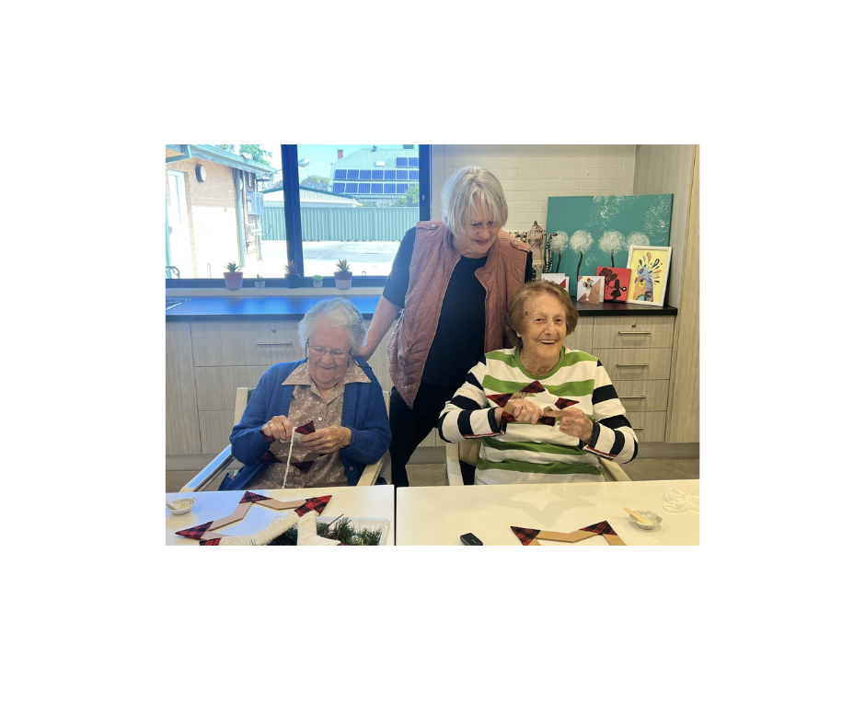

Spotlight

Jan Carter
My passion is being creative so naturally I pursued a career in Interior Design. What I loved most was doing property styling when I was living in Melbourne, especially the French Provincial style homes which was no mean feat as some were up to 80 square metres, 3 levels so lots of furniture, decorative accessories, artwork, bed linen etc etc to select, but I just loved it.

My husband Ted and I decided to make a rural change so moved to Deni in September 2019 where I have family. We bought a cute 1940s weatherboard home and did it up to suit us and have enjoyed living in Deni ever since.

Now I am spending my retirement doing craft sessions at Navorina with some of the ladies and having so much fun decorating the centre for their special occasions. It keeps my creative mind very active and thoroughly enjoying it.

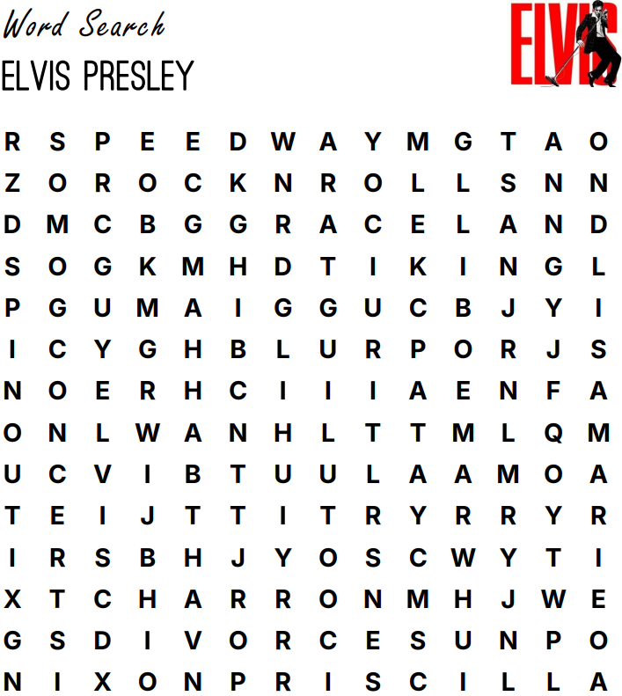
Tupelo Church Guitar Gyrations
Military Priscilla King Elvis
Lisa Marie Icon Speedway MGM
Graceland Concerts Nixon Rocknroll
Spinout Charro Rockabilly Grammy

