Navorina Nursing Home

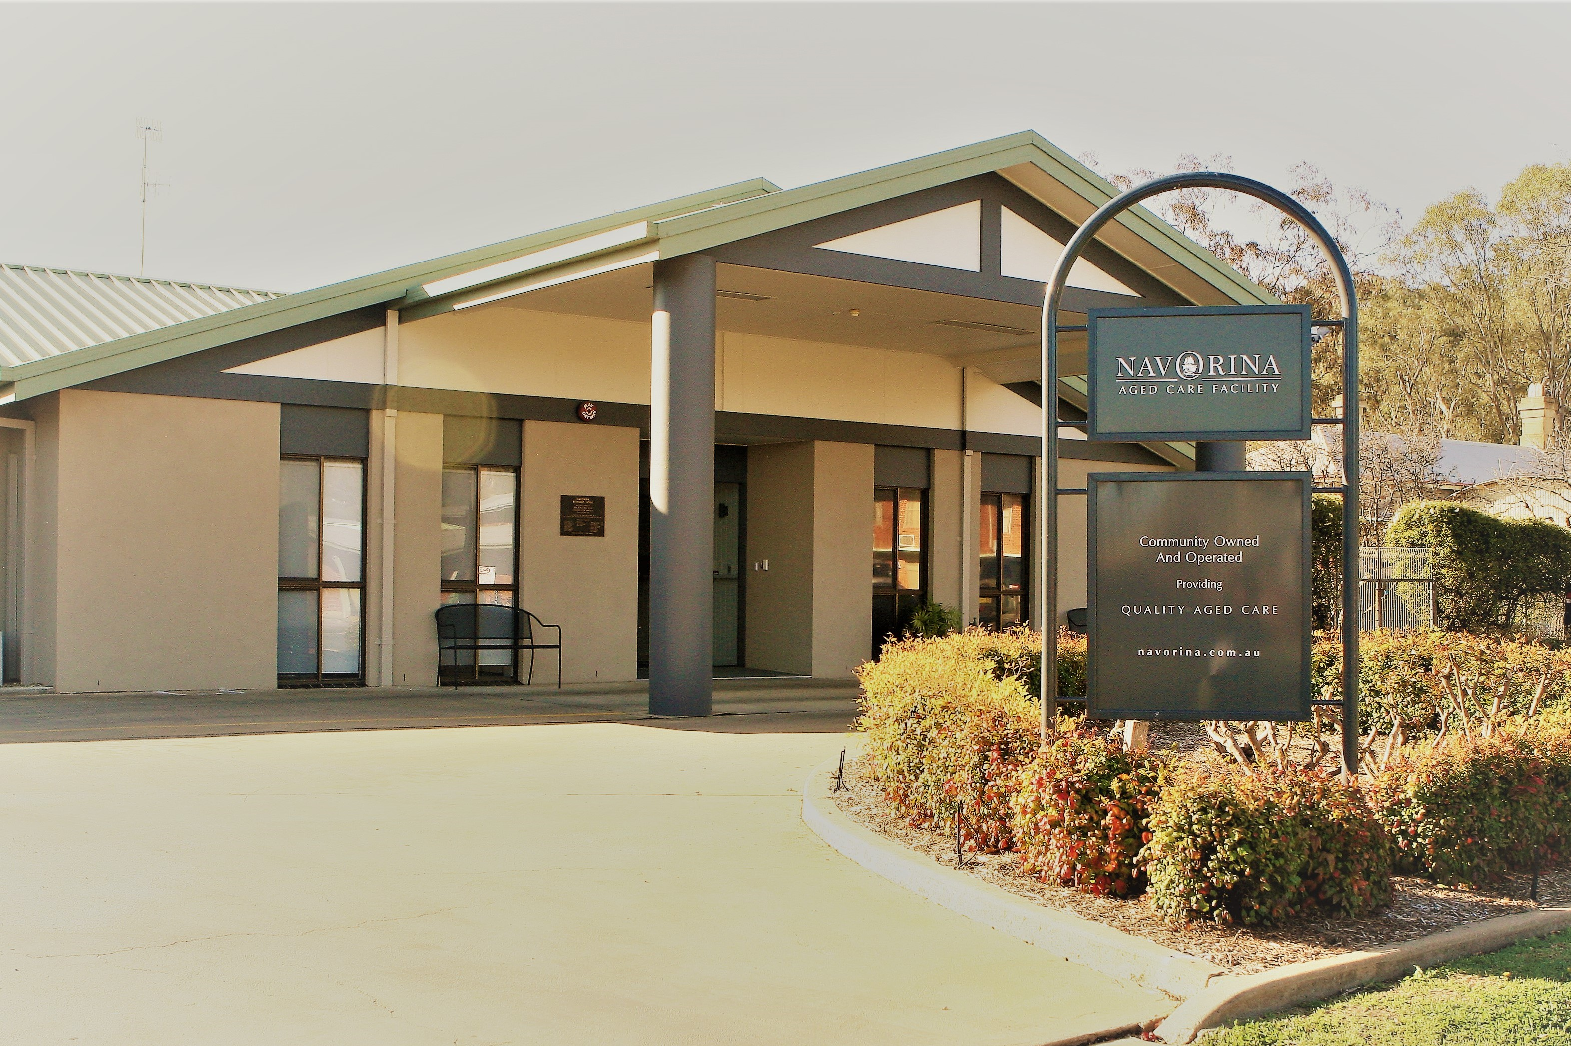

Navorina Nursing Home
Quality Aged Care

Welcome

RESIDENT HANDBOOK

NAVORINA NURSING HOME.

Welcome to Navorina Nursing Home.

The purpose of this booklet is to assist you in adjusting
to your new environment.
Please do not hesitate to ask if you have any problems.
We do hope that you enjoy your new surroundings.
If there is anything we can do to improve our service,
please let us know.

ADDRESS: 5-9 MACAULEY ST,
DENILIQUIN, NSW.
2710.
POSTAL ADDRESS: PO BOX 177
DENILIQUIN
NSW. 2710.
TELEPHONE: 03 58813944
FAX: 03 58813590
EMAIL: admin@navorina.com.au
VISITING HOURS: 8.00am to 7.30pm (AS COVID PERMITS)

Outside these hours you will need to ring the front door bell to gain entry

OFFICE HOURS: 9.00AM – 5.30PM.
MONDAY - FRIDAY.

PHILOSOPHY

Navorina Nursing Home aims to provide optimum standards of care for all residents whilst at the same time recognising that each resident is an individual and therefore deserves to be treated with dignity and respect. At all times the right of the residents to make decisions regarding their care will be recognised.

OBJECTIVES
* To achieve and maintain the highest standards of
Nursing Care.

* To recognise the rights of individuals to make
informed decisions regarding their care and their day
to day activities.

* To involve residents and staff in decision-making
regarding activities and practices in the nursing
home.

* To provide a secure, homelike environment which will
promote maximum independence for residents.

* To provide appropriate facilities for, and encourage
staff to participate in, ongoing education.

* To create conditions which will promote harmonious
relationships between residents, family and staff.

* To provide comfort and support to family and friends
of residents.

* To encourage community involvement in nursing home
activities, whilst at the same time promoting residents
involvement in the community activities.

* To comply with the Privacy Act and associated regulations.

* To comply with WHS Act and Regulations

* To comply with all legislation regarding the provision of high
level Care and employment of staff.

Living within a residential care facility should be akin to living at home with the added benefit of accessing immediate assistance and being able to be more involved in social activities.

This is not always how residents experience their lives here. Much has changed for them, along with their health problems they are adjusting to new conditions.

This brochure has been provided with the hope that we can provide the kind of support that will be meaningful and helpful.

Less contact with familiar people and places, new routines and ongoing change in health create added discomfort and for some, distress.
Our ability to cope with such circumstance is directly affected by how these changes are addressed.

HELPFUL SUGGESTIONS FOR FAMILY AND FRIENDS
- Ask if there is anything they may like you to do for them and do it. Keep your promises. Offer to write a letter, shop, run errands, call friends, take them for a walk (or wheelchair ride) outside.
- Reminisce if the person shows an interest. Refresh yourself on the times they have loved, or you have shared with them, so that you can offer a time of great enjoyment. Bring along a favourite piece of music. We have CD players available.
- Always include the person you are visiting in every conversation that takes place. Don’t talk over or around them. If they already have a visitor, offer to come back later. Having too many people in the room can be very tiring, and not beneficial in the long run.
- Find out if there is a need by the resident, to talk about their condition, thoughts and feeling. Do it simply by asking ‘Do you want to talk about anything in particular?’ Don’t divert them from a topic they may want to discuss.
- Let them talk, even if it is repetitious. Keep quiet and let the person express whatever is important to them.
- If the resident has entered a world beyond your understanding, if their mind wanders or if they can no longer talk, don’t run away. Sit quietly, hold a hand if it’s possible, and appreciate this special moment of care and love. Chances are they will sense your presence.
- Do not hurry him/her. Your visit may need to be short or long depending on their needs at the time. If you are running out of time, renegotiate another visit or talk to staff who may make alternative plans.
- Try to accept the person’s feelings. They may be going through challenging times and may experience moods and anxieties never before evident. Fears, tears, anger, resentment, depression and withdrawal are best dealt with openly and honestly.
- Tell them you are concerned about them but do not give advice. Your help lies in providing time to allow expression of those unpleasant emotions. The resident will gain much comfort from your compassion, understanding and willingness to listen. They will retain their dignity and you will remain a loving, caring, special member of their support network.
- Remember, quietness and companionship can sometimes be more helpful than talking. What’s crucial is that you are there for them.
- Encourage children to visit. Prepare them with information about what to expect and have them take along something to brighten up the person’s day-a drawing or painting, a handwritten story or poem, a breath-freshening sugar-free sweet, homemade biscuits, glycerine scented soap, or a favorite snack.
- Children are not as inhibited as adults and are consequently very honest with their questions. Most people will welcome their company. Be sensitive to how the person is responding. After your visit give the children the opportunity to speak about their experiences and you’ll also be helping them to grow openly with all aspects of life—pleasant and unpleasant.
- Sometimes a person’s condition is best assessed by the people who know them. Often visitors spend more time with them than care staff. As a visitor remember our important role. The subjects of your conversations with the resident are confidential matters, but what you observe in their concerns, activity, ability and personality may be of vital interest to staff.
- If you are concerned about anything, please take time to talk to staff before you leave. Likewise, on your way in, you could ask care staff if they have anything of importance to tell you prior to your visit.

PROPRIETORSHIP.
Navorina Nursing Home is a community owned Nursing Home managed by a voluntary Management Committee (Board). It is licensed by the Department of Human Services to accommodate sixty residents.

Navorina is set among pleasant lawns and gardens with outdoor facilities available to residents and their relatives. Navorina has secure fencing around its boundary with coded entry. Visitor parking is provided at the front of the nursing home as well as two disabled parking bays with ambulance access.

ELIGIBILITY FOR ADMISSION.
Our Nursing Home accommodation is provided for those persons in need of residential aged care. Every person who applies for admission to Navorina must have a current ACCR/ Support Plan, which is issued by the Aged Care Assessment Team, stating that residential aged care is approved.

APPLICATION FOR ADMISSION.
Prospective residents are referred to the nursing home by the Aged Care Assessment Team, the resident’s next of kin or Enduring Guardian. All persons requiring admission are considered and priorities are then determined according to need.

When the person’s name is given to the nursing home their name is placed on a waiting list. The Director of Nursing will liaise directly with the resident’s representative regarding placement.

Prior to admission, residents and their relatives are encouraged to look over the home and meet staff, orientate themselves and collect necessary paperwork from administration to complete admission formalities.

The CEO/Director of Nursing will notify the resident when a bed is available, and they can be admitted. It is helpful if relatives can be present when the resident is admitted.

ALCOHOL.
Residents may have alcohol within moderation. All alcohol is kept in the kitchen cool room. Residents are asked not to keep alcohol in their rooms. Family can provide alcohol for residents outside of Happy Hour. Happy hour is conducted on a weekly basis and relatives and friends are welcome to attend.

ACCOMMODATION.
Single rooms with ensuite and single rooms with shared ensuite are available, with basic daily fees being the same for each resident. Lump sum accommodation Fees (Refundable Accommodation Deposits or RADs) or daily periodic payments (Daily Accommodation Payments or DAPs) vary depending on the room type admitted to. This information is discussed with the DON and Finance Officer prior to admission.
current room costs are listed below:
Our current Refundable Deposits are set as below:
Chamberlain: $250,000.00
Riley: $330,000.00
Hunter Landale: $350,000.00
Inala Mirradong/McCann/ Puckawidgee: $400,000.00
You can find more information on daily accommodation fees relating to Navorina at https://www.myagedcare.gov.au/find-a-provider/aged-care-homes/1209408

On occasions it may be necessary to move the resident. This is likely to be due to a change in their needs/condition, which requires closer monitoring. Consultation with the resident and/or their family always takes place before any moves occur. Circumstances under which a move may be required is outlined in the Residential Agreement.

There are several private areas for residents and their families to use at Navorina, internally and externally. These areas can be used for quiet time, parties and confidential appointments. Please make arrangements with the Registered Nurse (R.N.) on duty or administration staff if an area is required for parties or appointments.

CLOTHING

A basic guide for clothing is

MEN:
Cardigan/ Full front zipper/buttoned windcheater (depends on preference): 5.
Shirts/tee-shirts (depends on preference): 6
Trousers/track pants (depends on preference): 5

Warm hat, scarf, coat or jacket for going outside in cold weather
Underpants: 5 pairs.
Pyjamas: Winter and Summer 4 of each
Singlets: 5
Socks: 5pairs.
Slippers: 1 pair.
Shoes: 1 pair with tie ups.
Sun Hats for hot weather

WOMEN:
Loose fitting Dresses. Elastic waist skirts & blouses (depends on preference): 6.
Cardigan/ Full front zipper/buttoned windcheater (depends on preference): 5.
Elastic top slacks/track pants (if desired): 5pairs.

Warm hat, scarf, coat or jacket for going outside in cold weather
Petticoats (if desired): 3
Underpants: 5
Bras (if desired) 2.
Nightgowns: Winter and Summer 4 of each.
Interlock tee shirt 4.
Singlets (if desired): 5.
Slippers: 1 pair.
Shoes: Flat heeled/ tie up shoes 2 pairs with non slip sole.
Sun Hat for hot weather

LAUNDRY
A laundry service is available for all residents. On admission labels will be printed with the resident’s name using Navorina’s labelling machine. Navorina will not accept responsibility for clothing and items that are not clearly labelled.

Items that need repair will be placed in a plastic bag in the resident’s wardrobe for families to take home and repair.

All clothing should be easy to launder and require minimal ironing. Only clothing that can be laundered in a washing machine and dried in a clothes drier will be laundered at Navorina. Residents (or their families) are responsible for the laundering and dry cleaning of delicate items of clothing and woollen items that cannot be washed in the washing machines.

CHURCH SERVICES.
Ministers of religion visit the nursing home on a regular basis. Residents can choose to have the minister visit them if they wish. Residents also have the right to refuse a visit from a minister. Some religions hold a regular church service at nursing home once a month. Residents can also attend the weekly services at their church if family wish to take them.

CONFIDENTIALITY.
All records and information relating to each resident is confidential. Information will not be disclosed/discussed with anyone other than those involved in the care of the resident without the resident's or families permission.

INFECTION CONTROL
As people age, their immune system becomes weaker leaving them prone to infections such as gastroenteritis, COVID and influenza.

Navorina follows infection control standards. To help us maintain these standards we ask that all visitors utilise the hand wash provided in the front foyer when visiting.
We ask that visitors refrain from visiting if they have signs or symptoms of gastroenteritis (vomiting and diarrhoea), COVID or influenza (flu).

Visitors are asked not to visit until
- 72 hours after the last episode of vomiting or diarrhoea.
- Until all signs of runny nose or cough have subsided.
- Until at least 7 days after initial infection with COVID
- If there is a public health order stating so.

QUALITY ASSURANCE, COMPLAINTS AND COMMENTS.
Navorina is committed to continuous improvement. Residents and their relatives are encouraged to discuss any matters of concern with the CEO/Director of Nursing. We are especially keen to learn of situations and circumstances where our standard of care has not met your expectations.

Navorina is also interested in any improvements or changes you may feel could be implemented to enhance our resident’s quality of life.

There are comments and complaints forms along with continuous improvement forms in the front foyer to the left at the first door as you enter the building, or you may speak to the CEO/Director of Nursing or the Registered Nurse on duty.

If you do not wish to utilise these avenues, formal complaints can be lodged with the Australian Aged Care Quality and Safety Commission.

CULTURAL CUSTOMS.
All attempts are made to ensure each resident’s cultural needs are met. If there is a problem in this area, please consult with the CEO/Director of Nursing.

DOCTORS
Each resident retains their choice of doctor. Doctors call regularly to review the residents' medical care, including treatment and medication. Where appropriate, the resident and their representative will be included in discussion regarding care planning.

If a relative wishes a resident to be visited by their doctor, apart from routine visits, it is requested that they notify the Registered Nurse on duty to organise this.

All outside appointments made for residents are to be accompanied by family member or Next of Kin, if not available Navorina staff may be able to accompany, however a fee may be charged up to $100.

Payment of doctor’s accounts is the responsibility of the resident or their representative.

MEDICATIONS
Prior to entry to the nursing home residents are able to choose their own chemist and a medication chart should be completed. Residents are responsible for their own accounts. There may be double ordering required for some medications and scripts as a back up precaution.

CARE PLANS
After an initial settling-in period, we develop a comprehensive Care Plan.

The care plan evolves over a number of months after the resident’s admission (with the initial information you provide to us), and changes whenever their needs change.

The care plan covers all aspects of their care needs – from specialised nursing care needs, to what they eat, what risks they face and their social emotional and cultural needs.

The Care plan is a live document and is designed to ensure that, at any point in time, staff are aware of the person’s assessed needs. It is their ‘story’ – no two resident’s care plans are the same.

When we give you a call every couple of months to discuss your loved one’s care (the ‘Care Evaluation’), we often discuss recent changes or issues they have – but you are also entitled (and able) to see a copy of the care plan

Sometimes we get it wrong – or simply don’t have the full picture of a person - perhaps you can assist us to fill in the gaps??

If you would like a copy of yours or your loved one’s care plan (provided we have the authority to give it to you) please do not hesitate just ask, or drop us an email on ceo@navorina.com.au , and we will send you a copy of the summary – or even the full 50 odd page document if you’d prefer.

DIETS AND MENUS.
Meals are cooked on the premises, with the menu being planned four weeks in advance. The resident / relative meeting is a venue where residents may make suggestions regarding menu choices. Forms are now available for resident’s choice of meals. Relatives of residents with memory loss or cognitive impairment can choose for them as well.

Residents with special dietary needs will, when necessary, be reviewed by the dietitian. Residents with difficulties swallowing, chewing, will be assessed by a RN and referred if necessary to the appropriate consultant. E.G. Dentist, Dietitian or Speech Pathologist.

The menu and food service is reviewed regularly by a qualified Certified Practicing Dietitian.

Snacks and Drinks are available at all times for residents. Please inform staff if you require help.

HERE ARE A FEW TIPS ON HOW YOU CAN HELP YOUR LOVED ONE ACHIEVE OPTIMAL NUTRITION AND MEET FOOD REGULATIONS

- Remember food safety. As people age, their immune system gets weaker. This is one reason why the elderly are more prone to food poisoning. Be careful providing the elderly with foods such as: soft cheeses, soft serve ice cream, processed deli meats, prepared salads, seafood, and foods with raw egg or undercooked cakes.

- Know if the food can be reheated. Most importantly, if reheating food, ensure it is heated to over 75 degrees Celsius for a minimum of 2 minutes.

- Know the type of food to bring in. Important foods for the elderly include protein rich foods such as dairy products (remembering to ensure they are ‘food safe’). Also, finger foods are generally easier to eat, and soft foods will help anyone with dental or chewing problems. When bringing in food we request that you fill in the Food Register Folder, that is kept at the admin sign in area.

- Discuss with Nursing Staff what food you have brought in. Nursing Staff are your loved one’s family when you are not around, so they need to know if you have brought in food. The staff can alert you to any concerns they may have. In some instances, it may be better not to bring in food for your loved one (e.g. if they are trying to lose weight). Try to think of other ways to show you care- for example take them out for the day, take in flowers or photos of your family.

- Get your loved one active! Although your loved one may be underweight, a small amount of light activity is very important in maintaining muscle and bone health. If they are able, go for a small walk outside in the garden.

- And most importantly – Make your visit enjoyable!!

SMOKING.
Smoking is not permitted in any building of Navorina Nursing Home. There is a designated smoking area for those who wish to continue to smoke. Residents are discouraged from smoking, however if they choose to continue to do so, a risk assessment is to assess the risks which may be associated with smoking. Residents deemed to be at risk may need to be accompanied whilst smoking by a staff or family member or wear a protective apron when smoking.

EMERGENCY PROCEDURES.
In the event of fire, the staff on duty will direct everyone in the building.
Residents are encouraged to remain where they are until a staff member attends them.

The Registered Nurse in Charge will direct all procedures during any emergency.
REMEMBER; Residents, volunteers and visitors must always follow the instructions of the person in charge.

In case of any emergency, residents and visitors are encouraged to remain where they are and wait for staff directions.

FURNITURE AND PERSONAL EFFECTS
Residents are encouraged to bring personal items into the nursing home. If you have a special request, please see the CEO/Director of Nursing. Pictures, bedspreads, doonas, pillows, pot plants, etc, are welcome. If you have any queries, please consult with the CEO/Director of Nursing.

ACCOMODATION FEES AND CHARGES.
These are set by the Commonwealth Department of Social Services. Please ask the Finance Officer for the current fee structure. Residents are requested to pay fees two weeks in advance.

Navorina provides basic medical supplies, equipment and appliances. Any specialised equipment is the responsibility of the resident or their relatives.

Toiletries are provided by Navorina including continence aids.

Charges incurred for medication, dental work, optometrist, hairdressing, outings clothing, books, newspapers and any other services are not included in the standard fee and are payable by residents as "extras." These extras will be separately billed by the supplier.

HAIRDRESSING/BEAUTY CARE.
Hairdressers attend the nursing home weekly. Families and relatives are responsible for the accounts. Alternatively, families may choose their own hairdresser. Face waxing is also available at the Nursing Home on a regular basis. Payment is made to the beautician, or an account can be organised (petty cash). Any resident who wishes to receive beauty treatment is asked to notify the Registered Nurse on duty.

PERSONAL CATERING
Is available for functions e.g. Birthdays at a cost per head. Please ask Hospitality Manager for more information.

MAIL
Inward mail is delivered daily (Monday - Friday). Outgoing mail should be handed to Activities Co-ordinator for postage.

MONEY AND VALUABLES.
Residents are discouraged from keeping sums of money or valuables in their room. Facilities are available for storing such items in the safe, but we advise relatives to take valuables home. All care will be taken with valuables, but we cannot accept responsibility for such items. A locked draw will be provided for each resident in their bedroom. On bringing in further valuables after admission it is the family’s responsibility to inform Navorina staff. The Lifestyle coordinator will take photos of valuables.

MEDICARE AND PENSION CARDS.
It is preferable that an up to date Medicare and Pension card be kept at the Administration Office, as they are required for doctors' visits and the purchase of pharmaceutical supplies.

NEWSLETTER.
A newsletter is printed on a regular basis at the nursing home and is distributed to all residents. Copies are available from reception or the Activities Coordinator.

RESIDENTS' MEETINGS.
Residents meet monthly to discuss life in the nursing home. This meeting is presided over by the Activities Coordinator and is open to all residents and/or their spokesperson.

RECREATIONAL ACTIVITIES.
Residents are encouraged to pursue existing interests and to acquire new ones if they wish. Residents can choose to participate in the activities conducted in the nursing home. The resident's choice not to participate will be respected.

Programs are organised for individual and group activities. Navorina provides a bus for transport to activities held outside Navorina.

Information regarding forthcoming events will be posted on the notice boards. Where possible, relatives and friends are invited to assist with social activities and outings. Such activities are important to the physical and mental wellbeing of the residents.

SECURITY OF TENURE.
Residents are able to remain at Navorina for as long as they require the care and services which are provided by this nursing home.

Residents whose condition warrants transfer to another facility which adequately caters for their specific needs will be assessed by the local Aged Care Assessment Team and appropriate accommodation will be arranged for them.

Residents and their relatives will be fully consulted if an occasion does arise when it is considered that the resident should be transferred to another facility. As previously stated, there are specific circumstances under which a resident may be required to leave the home. These circumstances are clearly articulated in the Resident Agreement.

Residents also have a right of appeal if they think that a transfer is not warranted, and the following avenues for appeal are available:

1. Director of Nursing
2. The Chairperson of the Board of Management.
3. Aged Care Assessment Team
4. Aged Care Quality & Safety Commission

LEAVE FROM THE NURSING HOME.
Residents are free to come and go from Navorina as they please. Please notify the Registered Nurse in advance of any proposed outings or absences. When leaving the nursing home, the resident/family must sign the resident outing register, which is kept at reception.

Residents are permitted overnight social leave from the nursing home for 52 days each year. The Commonwealth benefit continues to be paid during this time and the Residents' Contribution is also payable (Resident Fees), during this absence. When an emergency is declared (for example, during a COVID outbreak) the leave day limit may be waived by the government.

It will be necessary for the resident or their relative to sign a Resident Agreement stating that they agree to pay the applicable fees.

Should it become apparent that a resident will need to be absent from the home for more than 52 days in a calendar year it will be necessary to discuss this matter with Management.

SERIOUS ILLNESS OF A RESIDENT.
If a resident's condition changes significantly, the person nominated as the primary "next of kin" on the admission form will be notified.

It is preferred that a second person be nominated, in case the primary person is unable to be contacted. It is the responsibility of the nominated person to inform other relatives.

TELEVISION/RADIOS.
Television is available for communal use. Small televisions, maximum 34cm diagonal screen size with a wall mount is provided to each resident by Navorina. Radios may be kept at the bedside and will be the responsibility of the resident. Earphones may be required in order to minimise disturbance to other residents.

TELEPHONES.
Telephones are available for local calls only. A portable telephone is available at all times for a resident to take calls. Residents may choose to have a telephone connected in their rooms – this is at the arrangement and expense of the resident or their representative.

VOLUNTEERS.
Volunteers are a valuable part of Navorina. They assist in many areas including outings, activities, flower arranging, reading to residents and assisting with meals, special events, etc. If you would like to help in any of these areas please contact the Director of Nursing. Your assistance will be greatly appreciated. A current police check is required.

VOTING.
The Lifestyle coordinator assists Residents with their voting method of choice, alternatively postal votes may be utilised.

BEQUESTS.
If you would like to help Navorina to continue providing quality care to residents but you are not able to do so now, you may like to consider making a bequest from your estate. A bequest is simply an instruction in your Will that a part of your reserve savings and other assets are given to a particular person or organisation. A bequest may be part of your original will, or can be added later. Remember, a bequest in your Will can create a memorial that will last forever.

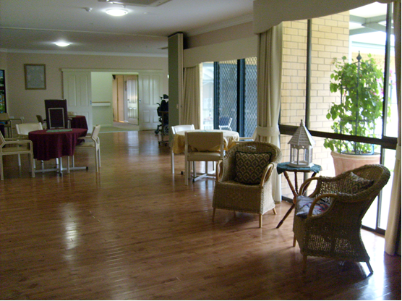

Charter of Aged Care Rights

Consumers

As a consumer, you have the option of signing the Charter of Aged Care Rights (the Charter).

You can receive care and services even if you choose not to sign.

If you decide to sign the Charter, you are acknowledging that your provider has given you:
- information about your rights in relation to the aged care service;
- information about your rights under the Charter; and
- a copy of the Charter signed by your provider.

Providers (“Navorina”)

Under the aged care law, providers are required to encourage all consumers to sign the Charter. The provider must give consumers a copy of the Charter that sets out:
- the consumer (or authorised person)’s signature (if they choose to sign);
- the full name of the consumer (and authorised person, if applicable);
- your signature;
- the date on which you gave the consumer a copy of the Charter; and
- the date on which you encouraged the consumer (or their authorised person) to sign the Charter.

The provider will also need to retain a copy of the signed Charter for your records

Charter of Aged Care Rights
I have the right to:
1. safe and high quality care and services;
2. be treated with dignity and respect;
3. have my identity, culture and diversity valued and supported;
4. live without abuse and neglect;
5. be informed about my care and services in a way I understand;
6. access all information about myself, including information about my rights, care and services;
7. have control over and make choices about my care, and personal and social life, including where the choices involve personal risk;
8. have control over, and make decisions about, the personal aspects of my daily life, financial affairs and possessions;
9. my independence;
10. be listened to and understood;
11. have a person of my choice, including an aged care advocate, support me or speak on my behalf;
12. complain free from reprisal, and to have my complaints dealt with fairly and promptly;
13. personal privacy and to have my personal information protected;
14. exercise my rights without it adversely affecting the way I am treated.

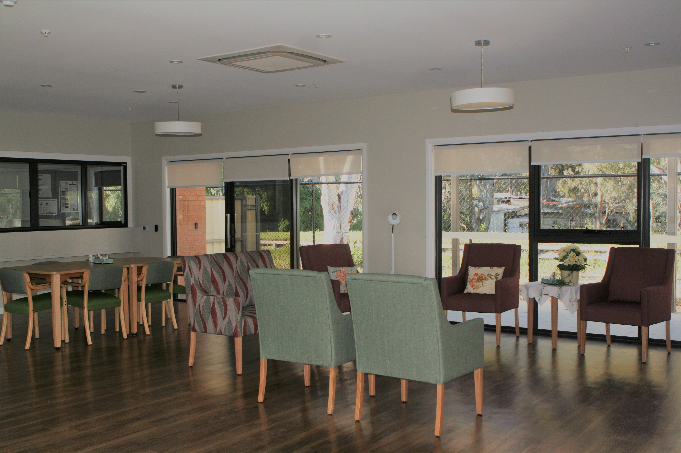

We hope your stay at Navorina will be enjoyable and fulfilling.

We are committed to ensuring your satisfaction

