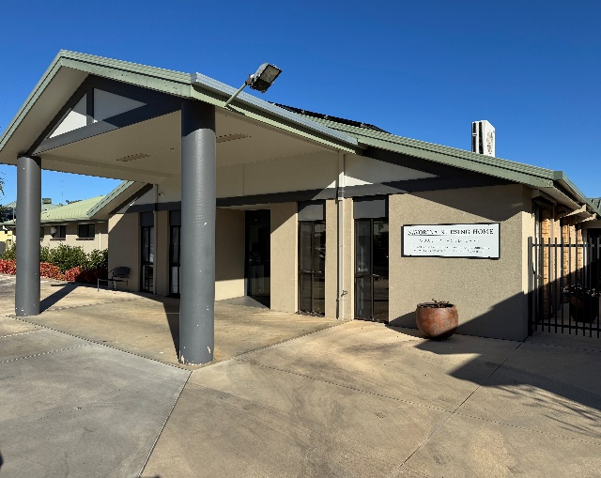

NAVORINA NURSING HOME
WELCOME HANDBOOK

Address: 5-9 Macauley Street, Deniliquin NSW 2710
Postal Address: PO Box 177, Deniliquin NSW 2710
Telephone: 03 5881 3944
Business Manager: businessmanager@navorina.com.au
CEO: ceo@navorina.com.au
Website: www.navorina.com.au

Office Hours: 9.00am to 5.00pm
Monday to Friday
Contents
WELCOME TO NAVORINA 3
PHILOSOPHY 3
USEFUL LINKS/ INFORMATION 3
APPLICATION FOR ADMISSION. 4
ACCOMMODATION PRICES. 4
FEES & CHARGES 5
CLOTHING GUIDE 6
LAUNDRY 6
ACTIVITIES & LIFESTYLE 7
ALCOHOL & SMOKING 7
FURNITURE AND PERSONAL EFFECTS 8
MONEY/ VALUABLES & PETTY CASH 8
HAIRDRESSING/BEAUTY CARE 8
MAIL 8
INFECTION CONTROL 9
PROPRIETORSHIP 9
CONFIDENTIALITY 10
QUALITY ASSURANCE, COMPLAINTS, COMPLIMENTS & COMMENTS 10
MEDICAL CARE 10
CARE PLANS 11
DIETS & MENUS 13
VOLUNTEERS 14
BEQUESTS & DONATIONS 14
FOUNDATION MEMBERS 14

WELCOME TO NAVORINA
We are delighted to have you join our nursing home.
This booklet is designed to help you settle comfortably into your new surroundings and make the most of what we have to offer.
If you have any questions, concerns, or need assistance, please don’t hesitate to reach out. We are here to support you every step of the way.
Our goal is to ensure you feel at home and enjoy your time with us. If there’s anything we can do to enhance your experience or improve our services, we’d love to hear from you.

PHILOSOPHY
Navorina Nursing Home aims to provide optimum standards of care for all residents whilst at the same time recognising that each resident is an individual and therefore deserves to be treated with dignity and respect. At all times the right of the residents to make decisions regarding their care will be recognised.

USEFUL LINKS/ INFORMATION
My Aged Care: https://www.myagedcare.gov.au/
Services Australia: https://www.servicesaustralia.gov.au/
Understanding Aged Care Fees: https://www.myagedcare.gov.au/understanding-costs
NSW Trustee & Guardian: https://www.nsw.gov.au/departments-and-agencies/trustee-guardian

APPLICATION FOR ADMISSION.
At Navorina Nursing Home, we provide comfortable accommodation for those in need of residential aged care. To apply for admission, you must have a current ACAT/Support Plan from the Aged Care Assessment Team that approves residential care.
We consider all applications and prioritise them based on individual needs. Before moving in, we encourage residents and their families to visit the home, meet our staff, and get familiar with the environment. You can also collect any necessary paperwork from our administration team to complete the admission process.
The Director of Care will inform the resident and their family when a bed becomes available and will set an admission date. It’s helpful if family members can be present during the admission.
Please remember we cannot process any admissions until all required paperwork is completed by the resident and/or their representative.

ACCOMMODATION PRICES.
At Navorina Nursing Home, we offer single rooms with ensuite bathrooms and single rooms with shared ensuites. The basic daily fees are the same for all residents. However, the lump sum accommodation fees (Refundable Accommodation Deposits or RADs) or daily accommodation payments (Daily Accommodation Payments or DAPs) depend on the type of room you choose. We discuss these details with the Finance Manager before you move in.

Our current room costs are listed below:
Chamberlain: $275,000.00
Riley – Tennis Court: $425,000.00
Riley- Courtyard: $425,000.00
Hunter Landale: $425,000.00
Inala Mirradong: $425,000.00
McCann: $425,000.00
Puckawidgee: $425,000.00

For more information on accommodation fees at Navorina, please visit the My Aged Care Site. https://www.myagedcare.gov.au/find-a-provider/aged-care-homes/1209408

FEES & CHARGES
All accommodation charges are set by the Department of Human Services. For the current fee structure, please contact the Finance Manager. Residents are required to pay their fees monthly in advance.
Navorina provides basic medical supplies, equipment, and appliances. Any specialised equipment not available at Navorina that may be required, will need to be arranged and funded by the resident or their family.

Navorina supplies standard toiletries and continence aids. If a resident prefers a specific product not provided by Navorina, it will need to be purchased by the family.

Items and services such as medications, dental and optometry, outings, and hairdressing are not included in the standard accommodation fee and are the responsibility of the resident:
Personal items such as clothing, books, and newspapers
These expenses will be billed separately by the supplier or managed through Navorina's petty cash system.

For further details or assistance, please speak with the Finance Manager or administrative staff.

CLOTHING GUIDE
MEN | WOMEN
2-3 Jumper/Cardigan  2-3 Coat/ Jacket  5-7 Shirts/ T-Shirts  2-3 Trousers/Track Pants  1 Hat  3 Pyjamas  5 Singlets  5 pairs Socks  2 pairs Shoes  1 Scarf  1 pair Slippers | 2-3 Jumper/Cardigan  2-3 Coat/ Jacket  5-7 Shirts/ T-Shirts  2-3 Trousers/Track Pants  1 Hat  3 Pyjamas/ Night Gowns  3 Bras  5 Singlets  5 pairs Socks  2 pairs Shoes  1 Scarf  1 pair Slippers

LAUNDRY
A laundry service is available for all residents. On admission labels will be printed with the resident’s name using Navorina’s label machine. Navorina will not accept responsibility for clothing and items that are not clearly labelled.
All clothing should be easy to launder and require minimal ironing. Only clothing that can be laundered in a HOT washing machine and dried in a HOT dryer will be laundered at Navorina. Residents (or their families) are responsible for the laundering and dry cleaning of delicate items of clothing and woollen items that cannot be washed in our machines.

ACTIVITIES & LIFESTYLE
Navorina provides a monthly activity calendar, available upon request. Copies are placed throughout the facility and in residents' rooms to keep everyone informed about upcoming events and activities.
A monthly newsletter is distributed to residents and sent to families with the monthly account statements. The newsletter includes important updates and information about life at Navorina.
Ministers of various religions regularly visit Navorina. Residents can choose to welcome a minister for a personal visit or decline if they prefer. Additionally, some religions hold monthly church services at the nursing home. Residents wishing to attend weekly services at their church can do so with family assistance for transportation.
Navorina is committed to meeting residents' cultural needs. Please inform staff of any specific requirements upon admission. Any concerns can be directed to the Director of Care. These offerings aim to support the social, spiritual, and informational needs of residents and their families.

ALCOHOL & SMOKING
Residents are kindly requested not to keep alcohol in their rooms. However, families may provide alcohol for residents. Navorina Happy Hour is held weekly, and relatives and friends are invited to join.
Smoking is strictly prohibited inside any building at Navorina Nursing Home. A designated smoking area is available for residents that may smoke.
Residents identified as being at risk may be required to have supervision while smoking, either by a staff member or family member. Residents must wear a protective apron for added safety. These policies are in place to ensure the comfort, safety, and well-being of all residents and staff.

FURNITURE AND PERSONAL EFFECTS
Residents are encouraged to bring personal items into the nursing home. Pictures, bedspreads, doonas, pillows, etc, are welcome. If you have any queries, please consult the Clinical Care Manager (CCM).

MONEY/ VALUABLES & PETTY CASH
Residents should avoid keeping money or valuables in their rooms. We offer a safe for storing valuable items, but we recommend that relatives take valuables home. While we will take care of your belongings, we cannot be responsible for lost or damaged items. Each resident will have a locked drawer in their room. If you bring in more valuables after moving in, please inform our staff. The Lifestyle Coordinator can help take photos and label your valuables.

Navorina uses a petty cash system for residents to pay for outings. For more information about this, please talk to our Finance Officer or the Lifestyle Coordinator.

HAIRDRESSING/BEAUTY CARE
Navorina has a Hairdresser attend every Thursday morning and a Beautician once a month. Payment is made via Navorina’s petty cash system. A price list is available on request.

MAIL
Inward mail is delivered daily (Monday-Friday). The PO Box is checked on Tuesdays and Thursdays. Outgoing mail can be handed to the Lifestyle staff for postage.

INFECTION CONTROL
To maintain high infection control standards:
- Visitors must use hand sanitiser provided in the front foyer.
- Visitors are asked not to visit if they have symptoms of gastroenteritis (vomiting or diarrhoea), COVID-19, or influenza.
Visitors should delay their visit until:
- At least 72 hours after the last episode of vomiting or diarrhoea.
- All signs of runny nose or cough have subsided.
- At least 7 days after initial COVID-19 infection.
- In accordance with any public health orders.

Please adhere to all policies to ensure the health, safety, and comfort of everyone at Navorina.
Your cooperation helps Navorina maintain the highest standards of care and safety for all residents.

PROPRIETORSHIP
Navorina Nursing Home is a community-owned facility governed by a dedicated voluntary Management Committee (Board). Licensed by the Department of Human Services, it provides care and accommodation for up to 60 residents.

Set amidst beautifully maintained lawns and gardens, Navorina offers outdoor spaces for residents and their families to enjoy. The facility is securely fenced with coded entry for safety and privacy.

Convenient visitor parking is available at the front of the nursing home, including two designated disabled parking bays and easy access for ambulances.

CONFIDENTIALITY
All resident records and information are treated with strict confidentiality. Information is only shared with individuals involved in the resident's care, unless explicit permission is given by the resident or their family.

QUALITY ASSURANCE, COMPLAINTS, COMPLIMENTS & COMMENTS
Navorina values feedback from residents and their families. Concerns or suggestions for improving the quality of care or resident experiences can be discussed directly with the Director of Care or the Registered Nurse on duty.

Feedback and Complaints:
Compliments, comments, complaints, and continuous improvement forms are available in the front foyer to the left of the first door as you enter.
Alternatively, formal complaints can be lodged with the Australian Aged Care Quality and Safety Commission

MEDICAL CARE
General Practitioners:
Doctors regularly review residents’ medical care, including treatment and medications.

Medications/ Pharmacy:
Residents may select their preferred pharmacy prior to admission, and a medication chart must be completed by their GP.
Residents or their representatives are responsible for settling accounts for medical services and medications.

Medical Appointments outside of Navorina:
Residents must be accompanied by a family member or next of kin for outside appointments.
If unavailable, Navorina staff may accompany the resident for a $100 fee.

CARE PLANS
At Navorina, we take great care in developing a comprehensive Care Plan for each resident after an initial settling-in period.

Individualised Planning:
The wholistic Care Plan is tailored to each resident, evolving over several months after admission and adjusting as their needs change. It addresses all aspects of care, including:
- Specialised nursing requirements
- Dietary preferences
- Risk management
- Social, emotional, and cultural needs

The Care Plan is a dynamic document designed to ensure that staff always have an up-to-date understanding of the resident's needs. It reflects their personal story, recognising that no two residents are the same.

Ongoing Evaluation:
Every few months, we conduct a Care Evaluation and contact you to discuss your loved one’s care. These discussions often focus on recent changes or concerns. You are also welcome to view the Care Plan at any time.

Collaboration and Feedback:
We strive for accuracy in understanding each resident, but occasionally, details might be missed or need adjustment. Your insights are invaluable in helping us refine the Care Plan to best meet your loved one’s needs.
Access to the Care Plan:
If you would like a copy of the Care Plan (and have the appropriate authorisation), please let us know. You can request a summary or the full document by contacting us at ccm@navorina.com.au.

Our goal is to provide the highest level of care by ensuring the Care Plan reflects the unique needs and preferences of each resident. Your partnership in this process is greatly appreciated.
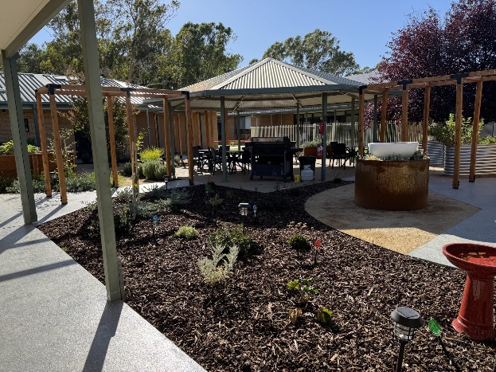

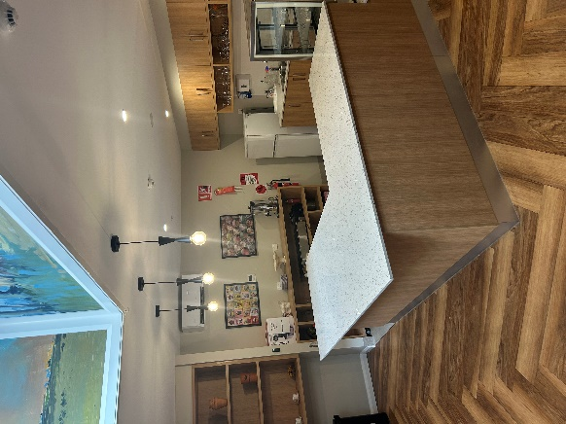
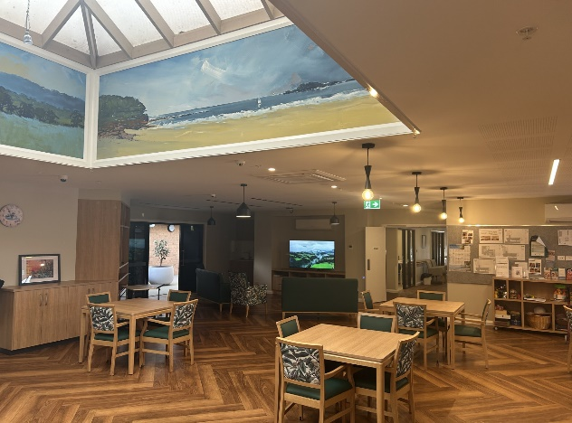

DIETS & MENUS
At Navorina, all meals are freshly prepared on-site, with menus thoughtfully updated to reflect seasonal changes.

Resident Input:
Residents are encouraged to provide feedback and suggestions regarding menu options during resident/relative meetings. Additionally, forms are available for residents to make meal preferences. For residents with memory loss or cognitive impairments, family members may assist in selecting meals.

Special Dietary Needs:
Residents with specific dietary requirements are reviewed by a dietitian as needed.
Those experiencing swallowing or chewing difficulties will be assessed by a Registered Nurse and referred to an appropriate consultant, such as a dentist, dietitian, or speech pathologist.

Menu Oversight:
The menu and food service are regularly reviewed by a Certified Practicing Dietitian to ensure quality and nutritional adequacy.

Snacks and Drinks:
Snacks and beverages are always available for residents. Please inform staff if assistance is required.

Residents are welcome to bring personal snacks not provided by Navorina. These items must be signed in at the reception area and labelled upon opening to ensure safe handling and storage.

Navorina strive to accommodate residents’ dietary preferences and needs while maintaining a high standard of care and nutrition.

BEQUESTS & DONATIONS
If you wish to support Navorina’s mission of providing quality care to residents but are unable to do so at this time, you might consider making a bequest as part of your estate planning.
A bequest is a provision in your Will that designates a portion of your savings or assets to a specific individual or organisation, such as Navorina. This can be included in your original Will or added later through an amendment.

A bequest not only supports our ongoing care and services but can also serve as a lasting memorial, ensuring your generosity is remembered for generations.

VOLUNTEERS
Volunteers play an integral role at Navorina, enhancing the lives of our residents through activities such as:
- Assisting with outings and activities
- Helping with meals
- Supporting special events

If you are interested in volunteering, please contact Bernadette, our lifestyle coordinator. Your time and skills are greatly valued and make a meaningful difference in our residents’ lives.
Please note: All volunteers are required to provide a current police check as part of the onboarding process.

FOUNDATION MEMBERS
If you are interested in joining our Foundation, please see Skye our Business Manager for more information.
Membership is a $10.00 fee per year.

