Navorina Nursing Home
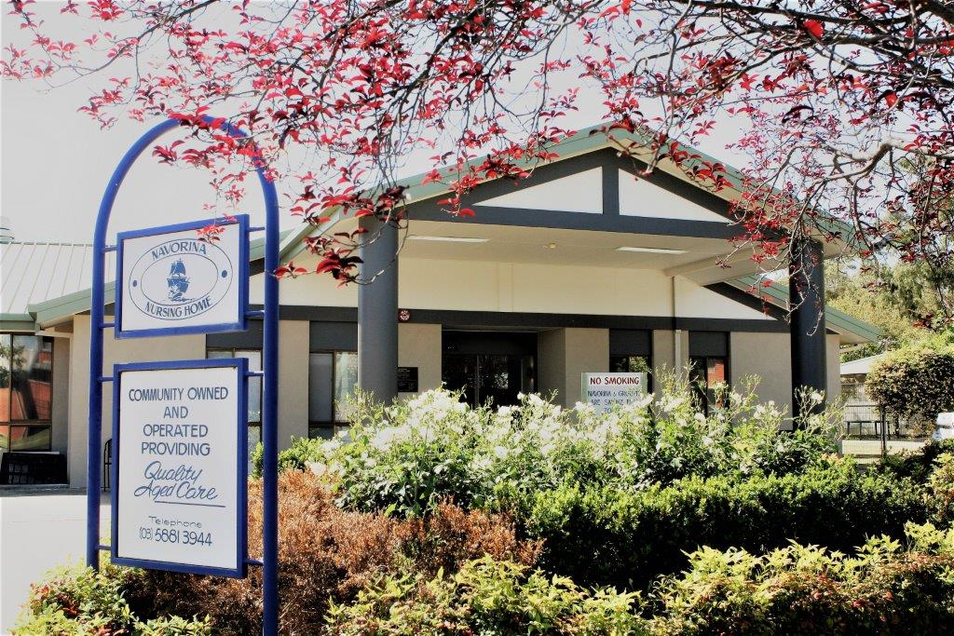

Volunteers
Policies & Procedures
Handbook

Table of Contents
Table of Contents 2
Welcome to Navorina 3
Orientation 4
Mission Statements 4
Philosophy 4
Objectives of our Volunteer Program 4
Introduction Program 5
Navorina Code of Practice 5
Police Check 5
Confidentiality 5
Reporting for Duty 5
Smoking 5
Alcohol 5
Accident and Incident Reports 6
Workplace Health & Safety 6
Infections 6
Fire Safety & Emergency Manual 6
Good Volunteers Guide 6
Good Volunteers Will…
Tips for Friendly Visiting 7
Welcome! 7

Welcome to Navorina!
Welcome to Navorina. Your assistance in helping us provide care for our residents is greatly appreciated and we hope that you will share the personal satisfaction we experience from working as a team and from sharing in the lives of our Senior Citizens.
Our aims are:
- To provide and maintain the best possible standards of health care with compassion and respect for their rights.
- To appreciate their individualities and their needs in a holistic manner.
- To promote and maintain a friendly and warm atmosphere focusing on the optimistic and joyful aspects of life.

Director of Nursing: | Nicole Smith
Business Manager: | Skye Parks
Clinical Care Manager: | Erika Quiling
Diversional Therapist: | Bernadette Werner & Penny Clines

Navorina is a 60-bed facility for high care residents. We are a not-for-profit organisation.
If you have any problems or questions do not hesitate to discuss them with the Lifestyle Co-Ordinators or the DON.

Orientation
- Volunteers will attend an orientation session of two hours before starting.
- Volunteers will work under supervision of Lifestyle Co-Ordinator’s or other staff until confidence and competence is achieved.
- Volunteers are expected to comply with this Facility’s Policies & Procedures and Code of Ethics.

Mission Statements
- We believe that every resident is entitled to a holistic care which assures their spiritual, emotional, physical, and social wellbeing.
- We believe in always protecting the privacy and dignity of residents.
- We believe in sustaining the independence of residents for as long as it is practical and safe.
- We will endeavour to encourage residents to continue to maintain contact with the community at large and to maintain old friendships and leisure pursuits.

Philosophy
Navorina Management and staff will strive to provide the highest standards of care to maintain our residents’ physical, spiritual and emotional wellbeing.
A harmonious and sympathetic approach will be extended to relatives, visitors and volunteers in a supportive and caring environment.

Objectives of our Volunteer Program
- To assist staff in providing an environment of warmth and cheerfulness that focus of the positive aspects of human life.
- To expose residents to other people and talents in the community other than staff.
- To promote personal growth development and spiritual fulfilment through one-on-one interaction.
- To enhance and expand leisure activities.
- To capitalise on the skills and competencies being offered by the community.

Induction Program

Navorina’s Code of Practice
- We will strive to make your experience happy and fulfilling.
- Provide volunteers with a safe workplace.
- Provide appropriate and adequate insurance coverage for volunteer staff.
- Provide support and guidance whenever needed.
- Acknowledge the rights of volunteer staff.
- Reimburse any money spend on behalf of the Facility.
- Treat volunteers as valuable members of our Facility’s team.
- Recognise the contributions of volunteer staff.

Police Check
In line with the Department of Health’s Policy, all volunteers are requested to submit to a national Criminal record check.

Confidentiality
- Resident’s medical condition and their private lives are to be treated with the outmost respect and confidentiality.
- Residents’ records are not to be removed from Facility.
- Request for Resident information by non-authorised persons are to be directed to the Clinical Manager or the CEO.
- Volunteers will sign a ‘Confidentiality Form’ before commencing duties.

Reporting for Duty
Volunteers should report to the coordinator (failing that, report to senior staff) and sign in on arrival for duties.
They are also expected to wear their name badges provided by the Lifestyle Co-Ordinator.
Volunteers should be able to support residents whilst maintaining a professional distance. Navorina policy states that you are not allowed to accept gifts or monies from residents.

Smoking
- Smoking is not permitted on Navorina grounds.

Alcohol
If there is indication of excess alcohol consumption, disciplinary action will be taken.

Accident and Incident Reports
All accidents and incidents (regardless of how minor) are to be reported to a senior staff member.

Workplace Health & Safety

Infectios
Volunteers have a responsibility to take care of their own health by following policies and procedures to prevent the spread of infection.

Fire Safety & Emergency Manual
Volunteers should become acquainted with the Fire Safety Precautions prior to commencing volunteer duties.
It is expected that all volunteers will be able to discern without hesitation:
- Fire exit.
- Emergency assembly points.
- Procedure in the event of alarm

Good Volunteers Guide
- Maintain good relationships with staff, and residents.
- Establish a regular time for volunteer service.
- Be consistent, dependable and on time. Ring if you cannot come.
- Keep completely confidential what you hear and see in the course of your voluntary work.
- Offer a willing ear without being over sympathetic. Avoid emotional Involvement.
- Your function is to help with activities, engaging with the residents in a warm and understanding manner, without ‘smothering’ them with attention.
- Always report to staff if taking a resident outdoors for a walk.
- Notify Management and refrain from duties if you are feeling unwell e.g., flu, virus, herpes simplex.
- Be sensitive to body language and take cues from it.
- Protect and safeguard the interest of residents with dementia.
- Only handle equipment in Facility if instructed to do so.
- Will not offer legal advice to residents.

ips for Friendly Visiting
- Take time to play simple games - cards, dominoes, scrabble, etc. if that is what the resident would like to do.
- Be a good listener - be interested and responsive even to stories you have heard before. Learn to interrupt and give new focus to the story.
- Encourage residents to reminisce. This is a good mental exercise and usually a happy experience for the resident.
- Be sensitive to the concentration capacity of residents - older people often tire quickly.
- When reading to residents, ask them what they would like to hear or choose items you think will appeal to them.
- If residents speak sharply or find fault with you, the staff, or their families, do not take it personally. Remember that they often cannot vent their frustrations in other ways.
- Address residents formally; Mr., Mrs, and Miss unless residents specify otherwise.

Welcome!
We value your contribution and wish you to a long stay at Navorina.

