Navorina Nursing
Home
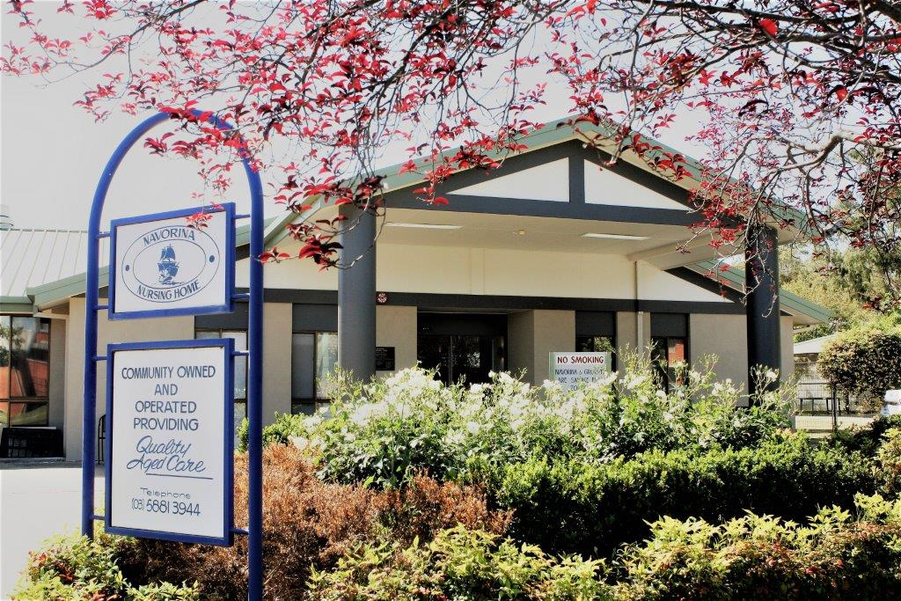
COMMUNITY OWNED AND OPERATED
Phone: (03) 58813944
Employee Information Handbook
WELCOME to Navorina Nursing Home  We trust your time with us will be meaningful and rewarding.  Our main objective to our customers is to provide professional quality care. Our Mission, Vision is located at the rear of this information booklet. Working in aged care requires expertise to provide the care required. That is why you have been selected to join our caring team. Your loyalty, confidentiality and understanding will do much to enhance resident lifestyle and wellbeing. Our working environment is happy and cheerful AND we intend to keep it that way so if you have any complaints or grievances talk to the Chief Executive Officer or Business Manager it will certainly help to clear the air and avoid stress. Relevant legislation to maintain your rights and the rights of others governs all procedures. Policy and procedures relating to all aspects of your work are available for your perusal. Please refer to these references. They are located in your work area if in doubt ask! We have adopted the principle that no question is a dumb question.  Continuous Improvement  Navorina Nursing Home strives to monitor what we do and how we could do it better. This may be through internal and external audits, surveys or through discussion. We value your input in the Continuous Improvement program. Staff are encouraged to verbalise comments complaints or suggestions at meetings, or to complete a Continuous Improvement Form to formalise issues.  Mobile Phones  Please ensure your mobile phone is switched off whilst you are working. Please ensure calls are made during your allocated breaks. If there are circumstances that require you to have your mobile on see your Area manager or the Director of Nursing.  Education  Regular education sessions are conducted at Navorina. Staff are also supported to attend external courses. Compulsory attendance is required for  Fire Safety  Elder Abuse  Infection Control  - Manual Handling  Staff Appraisals  Staff appraisals are conducted yearly to determine your further direction and work performance. Appraisals may be conducted more frequently by you or your employee if concerns are raised by either party.  Meals  For a small fee a meal can be ordered from the kitchen. Please fill out the daily meal sheet form located outside the kitchen door. No staff member can enter the kitchen to help himself or herself.  Orientation  You will receive an orientation prior to performing your duties as stipulated in your job description. A checklist induction will ensure you are orientated to Navorina’s policy and procedures.  Privacy  Navorina Nursing Home complies with all privacy legislation and you are reminded to be aware that confidentiality must be observed at all times.  Exit Interviews will be offered to employees who are departing. This process will take place with the departing employee and their direct manager to identify areas of improvement such as job satisfaction, culture and strategies to improve retention. | Infection Control  Effective Hand washing is the single most important factor in minimising the spread of infection. Infection Control is an annual Mandatory training requirement, and there is a comprehensive Infection Control Policy Manual to guide your practice.  Workplace Health & Safety  All staff must abide the WHS regulations and legislation. There are policies and procedures in place for all areas of Workplace health & Safety.  You will be informed about incident reporting, hazard reporting and near miss reporting. These procedures are also detailed in the Policy and Procedure manuals. This will be brought to your attention during orientation. You must be aware of all these policies and be familiar with them.  Navorina Nursing Home has a no lift policy, this is also detailed in Policy and Procedures Manual.  Staff are required to park their cars in the car park at night and are escorted safely to cars after hours.  Dress code  The Chief Executive Officer, Education/Quality Manager, Direct Manager or delegate will advise you on the requirements for uniform.  Car Park  Car space is available out front of the building. For evening and night duty staff we recommend parking atr own risk.  Pay day  You will be paid per your award. Copies of the Enterprise Bargaining Agreement are available in the Staff room. You are responsible for signing in and out in Deputy for each shift worked. This is situated in the foyer, and will be shown to you during orientation. Pay is calculated fortnightly, Monday to Sunday. Your pay will be available on the Thursday unless otherwise stipulated. Your bank details will need to be provided to the Business Manager.  You will be informed how to carry out changes to your roster, how to make a pay enquiry and leave requests.  Gifts, witnessing signatures, acting as signatory  Staff are not to accept monetary gifts from residents, resident’s family members, resident’s friends or persons appointed by resident.  Staff may accept small token gifts, which may include lottery tickets.  Staff are not to sign or witness documents. All requests are to be referred to the Director of Nursing or Business Manager.  Staff are not to have access to or act as signatories to residents bank accounts under any circumstances.  If unsure any of these matters refer to the Director of Nursing.  Smoking  Navorina is a smoke free work environment. No smoking is permitted on the grounds  Happiness is being part of the team
Our Vision  ‘To be an innovative and dynamic industry leader, providing quality and holistic residential care services’  Our Mission To Provide:  - Quality care & Service  - A Safe, Comfortable & friendly living environment  - 3. A professional and respected work force  - 4. A lifestyle that encourages participation in community life  - 5. Ongoing regulatory compliance  Our Values  - Professionalism – maintain standards consistent with contemporary practice  - Honesty – To be open, truthful and trustworthy  - Equity – To be fair and impartial  - Respect – To treat each of our stakeholders with dignity, courtesy, empathy and as individuals  - Integrity – To be ethical, confidential and accountable  - Quality – Excellence through innovation and applied learning  - Caring – To be sensitive and responsive to each other  - Flexibility - To be flexible and open to change  Our Philosophy  “Navorina Nursing Home aims to provide optimum standards of care for all residents whilst at the same time recognising that each resident is an ‘individual’ and therefor deserves to be treated with dignity and respect. At all times the right of the residents to make decisions regarding their care will be recognised.” | Our Objectives  1. To achieve and maintain the highest standard in nursing care.  2. To recognise the rights of individuals to make informed decisions regarding care and day to day activities.  3. To involve residents and staff in decision making regarding activities and practices in the nursing home.  4. To provide a secure home-like environment which will promote maximum independence for residents.  5. To provide appropriate facilities and encourage ongoing education.  6. To create conditions which will promote harmonious relationships between residents, family and staff.  7. To provide comfort and support to family and friends of residents.  8. To encourage community involvement in nursing home activities whilst at the same time promoting involvement in community activities.  9. To comply with the Privacy Act and associated Regulations.  10. To comply with Workplace Health and Safety Acts and Regulations.  11. To comply with all legislation regarding the provision of high level aged care and employment of staff.  Our Commitment to Quality  Our commitment to quality is reflected in our Vision, Mission, Core Values, Objectives and Philosophy Statements. It is reinforced in our policy on Continuous Improvement.

